Child Psychopathology Reference Guide

Jeffrey Unterberger
Chatham University
Department of Counseling Psychology

Table of Contents
Part I. Common Disorders of Childhood 7
Depressive Disorders 7
Major Depressive Disorder 7
Persistent Depressive Disorder (Dysthymia) 8
Disruptive Mood Dysregulation Disorder 9
Unspecified Depression 10
Prevalence of Depressive Disorders 10
Theories of Depression 10
Developmental Differences in Depression 11
Developmental Course 11
Developmental Model of Depression 12
Anxiety Disorders 12
Separation Anxiety Disorder 12
Selective Mutism 13
Obsessive-Compulsive Disorder 13
Generalized Anxiety Disorder 15
Social Anxiety Disorder (Social Phobia) 15
Prevalence 16
Developmental Course 16
Anxiety Sensitivity 16
Temperament 17
Developmental Model of Anxiety 17
Trauma-and Stressor-Related Disorders / Attachment-Related Disorders 18
Reactive Attachment Disorder 18
Disinhibited Social Engagement Disorder 19
Posttraumatic Stress Disorder 20
Acute Stress Disorder 24
Adjustment Disorder 26
Developmental Models and Mechanisms of Stress 26
Stress Physiology: Hypothalamic-pituitary-adrenal (HPA) Axis 27
Developmental Model of Attachment 31
Intellectual Disability Disorder 31
Intelligence 31
Diagnostic Criteria 31
Limitations of the IDD Diagnosis 34
Historical Perspectives 35
Neuroscience Perspectives 36
Autism Spectrum Disorder 36
Diagnostic Criteria 36
Social Attention 39
Joint Attention 39
Face perception 40
Emotional Perception 40
Imitation 40
Symbolic Play 41
Language and communication 41
Restrictive Repetitive Behaviors (RRBs) 42
Developmental Model of ASD 43
Attention-Deficit/Hyperactivity Disorder (ADHD) 43
Diagnostic Criteria 43
Holistic Perspectives 46
Prevalence 46
Development and Continuity 46
Contextual Factors 47
Intervention 48
Schizophrenia 48
Diagnostic Criteria 49
Prevalence 50
Developmental Continuities 50
Premorbid Developmental Anomalies (Early Warning Signs) 51
Treatment 51
Developmental Model of Schizophrenia 52
Eating Disorders 53
Anorexia Nervosa 53
Bulimia Nervosa 54
Binge Eating Disorder 54
Medical complications 55
Prevalence 56
Cognitive Factors 56
Developmental Model of Eating Disorders 57
Substance-Use Disorder 57
Alcohol Use Disorder 57
Cannabis Use Disorder 59
Pathways to Substance Use Disorder 60
Risk factors: 61
Developmental timing 61
Developmental Model of Substance Use Disorder 62
Conduct-Related Disorders 62
Oppositional-Defiant Disorder 62
Conduct Disorder 63
ODD vs. CD 65
Antisocial Personality Disorder 66
Intermitted Explosive Disorder 66
Callous and Unemotional Traits 67
Prevalence 67
Comorbidity 68
Developmental Continuities 68
Temperament 68
Risk factors 68
Protective factors 69
Developmental Model of Antisocial Behaviors 69
Borderline Personality Disorder 69
Diagnostic Criteria 70
Prevalence 70
Developmental Continuities 70
Risk factors 71
Developmental Model of BPD 71
Part II. Diagnosis Nonspecific Contextual Factors 71
Self-Processes in Childhood 71
Very Early Childhood (2-4) 72
Early to Middle Childhood (5-7) 72
Middle-to-late Childhood (8-10) 73
Early adolescence (11-13) 73
Middle adolescence (14-16) 74
Late adolescence (17-19) 74
Roots of Consciousness 74
Awareness at birth and in infancy 74
Peer Relations 75
Young Children 75
School aged Children 75
Adolescence 75
Family Systems 76
Bowen Family Systems 76
Minuchin’s Structural Family Theory 76
Functional Family Perspective 76
Holism & viewing family as a system 77
Boundaries 77
Change Processes in Family Systems 77
Emotional Security Theory 78
DSM- Limitations 79
Cognitive Risk factors 79
Models 79
Processes 80
Cognitive style 80
Summary of Cognitive Deficits by Disorder 81
Child Maltreatment 82
Spanking as a punishment 82
Risk factors 82
Risk of Psychopathology after Child Maltreatment 83
Protective factors 83
Divorce, Separation, and Loss 83
Risk Factors of Divorce 83
Protective Factors of Divorce 84
Death of a Parent 84

Part I. Common Disorders of Childhood

Depressive Disorders

Major Depressive Disorder
Diagnostic Criteria:
A. Five (or more) of the following symptoms have been present during the same 2-week period and represent a change from previous functioning; at least one of the symptoms is either (1) depressed mood or (2) loss of interest or pleasure. Note: Do not include symptoms that are clearly attributable to another medical condition.
1. Depressed mood most of the day, nearly every day, as indicated by either subjective report (e.g., feels sad, empty, hopeless) or observation made by others (e.g., appears tearful). (Note: In children and adolescents, can be irritable mood.)
2. Markedly diminished interest or pleasure in all, or almost all, activities most of the day, nearly every day (as indicated by either subjective account or observation).
3. Significant weight loss when not dieting or weight gain (e.g., a change of more than 5% of body weight in a month) or decrease or increase in appetite nearly every day. (Note: In children, consider failure to make expected weight gain.)
4. Insomnia or hypersomnia nearly every day.
5. Psychomotor agitation or retardation nearly every day (observable by others, not merely subjective feelings of restlessness or being slowed down). 6. Fatigue or loss of energy nearly every day.
7. Feelings of worthlessness or excessive or inappropriate guilt (which may be delusional) nearly every day (not merely self-reproach or guilt about being sick).
8. Diminished ability to think or concentrate, or indecisiveness, nearly every day (either by subjective account or as observed by others).
9. Recurrent thoughts of death (not just fear of dying), recurrent suicidal ideation without a specific plan, or a suicide attempt or a specific plan for committing suicide.
B. The symptoms cause clinically significant distress or impairment in social, occupational, or other important areas of functioning.
C. The episode is not attributable to the physiological effects of a substance or to another medical condition.
Note: Criteria A–C represent a major depressive episode.
Note: Responses to a significant loss (e.g., bereavement, financial ruin, losses from a natural disaster, a serious medical illness or disability) may include the feelings of intense sadness, rumination about the loss, insomnia, poor appetite, and weight loss noted in Criterion A, which may resemble a depressive episode. Although such symptoms may be understandable or considered appropriate to the loss, the presence of a major depressive episode in addition to the normal response to a significant loss should also be carefully considered. This decision inevitably requires the exercise of clinical judgment based on the individual’s history and the cultural norms for the expression of distress in the context of loss.1
D. The occurrence of the major depressive episode is not better explained by schizoaffective disorder, schizophrenia, schizophreniform disorder, delusional disorder, or other specified and unspecified schizophrenia spectrum and other psychotic disorders.
E. There has never been a manic episode or a hypomanic episode. Note: This exclusion does not apply if all the manic-like or hypomanic-like episodes are substance-induced or are attributable to the physiological effects of another medical condition.

Persistent Depressive Disorder (Dysthymia)
Diagnostic Criteria 300.4 (F34.1)
This disorder represents a consolidation of DSM-IV-defined chronic major depressive disorder and dysthymic disorder.
A. Depressed mood for most of the day, for more days than not, as indicated by either subjective account or observation by others, for at least 2 years. Note: In children and adolescents, mood can be irritable and duration must be at least 1 year.
B. Presence, while depressed, of two (or more) of the following:
1. Poor appetite or overeating.
2. Insomnia or hypersomnia.
3. Low energy or fatigue.
4. Low self-esteem.
5. Poor concentration or difficulty making decisions.
6. Feelings of hopelessness.
C. During the 2-year period (1 year for children or adolescents) of the disturbance, the individual has never been without the symptoms in Criteria A and B for more than 2 months at a time.
D. Criteria for a major depressive disorder may be continuously present for 2 years.
E. There has never been a manic episode or a hypomanic episode, and criteria have never been met for cyclothymic disorder.
F. The disturbance is not better explained by a persistent schizoaffective disorder, schizophrenia, delusional disorder, or other specified or unspecified schizophrenia spectrum and other psychotic disorder.
G. The symptoms are not attributable to the physiological effects of a substance (e.g., a drug of abuse, a medication) or another medical condition (e.g. hypothyroidism).
H. The symptoms cause clinically significant distress or impairment in social, occupational, or other important areas of functioning.
Note: Because the criteria for a major depressive episode include four symptoms that are absent from the symptom list for persistent depressive disorder (dysthymia), a very limited number of individuals will have depressive symptoms that have persisted longer than 2 years but will not meet criteria for persistent depressive disorder. If full criteria for a major depressive episode have been met at some point during the current episode of illness, they should be given a diagnosis of major depressive disorder. Otherwise, a diagnosis of other specified depressive disorder or unspecified depressive disorder is warranted.

Disruptive Mood Dysregulation Disorder
Diagnostic Criteria 296.99 (F34.8):
A. Severe recurrent temper outbursts manifested verbally (e.g., verbal rages) and/or behaviorally (e.g., physical aggression toward people or property) that are grossly out of proportion in intensity or duration to the situation or provocation.
B. The temper outbursts are inconsistent with developmental level.
C. The temper outbursts occur, on average, three or more times per week.
D. The mood between temper outbursts is persistently irritable or angry most of the day, nearly every day, and is observable by others (e.g., parents, teachers, peers).
E. Criteria A–D have been present for 12 or more months. Throughout that time, the individual has not had a period lasting 3 or more consecutive months without all of the symptoms in Criteria A–D.
F. Criteria A and D are present in at least two of three settings (i.e., at home, at school, with peers) and are severe in at least one of these.
G. The diagnosis should not be made for the first time before age 6 years or after age 18 years.
H. By history or observation, the age at onset of Criteria A–E is before 10 years.
I. There has never been a distinct period lasting more than 1 day during which the full symptom criteria, except duration, for a manic or hypomanic episode have been met.
Note: Developmentally appropriate mood elevation, such as occurs in the context of a highly positive event or its anticipation, should not be considered as a symptom of mania or hypomania.
J. The behaviors do not occur exclusively during an episode of major depressive disorder and are not better explained by another mental disorder (e.g., autism spectrum disorder, posttraumatic stress disorder, separation anxiety disorder, persistent depressive disorder [dysthymia]).
Note: This diagnosis cannot coexist with oppositional defiant disorder, intermittent explosive disorder, or bipolar disorder, though it can coexist with others, including major depressive disorder, attention-deficit/hyperactivity disorder, conduct disorder, and substance use disorders. Individuals whose symptoms meet criteria for both disruptive mood dysregulation disorder and oppositional defiant disorder should only be given the diagnosis of disruptive mood dysregulation disorder. If an individual has ever experienced a manic or hypomanic episode, the diagnosis of disruptive mood dysregulation disorder should not be assigned.
K. The symptoms are not attributable to the physiological effects of a substance or to another medical or neurological condition.

Unspecified Depression
This category applies to presentations in which symptoms characteristic of a depressive disorder that cause clinically significant distress or impairment in social, occupational, or other important areas of functioning predominate but do not meet the full criteria for any of the disorders in the depressive disorders diagnostic class. The unspecified depressive disorder category is used in situations in which the clinician chooses not to specify the reason that the criteria are not met for a specific depressive disorder and includes presentations for which there is insufficient information to make a more specific diagnosis (e.g., in emergency room settings).

Prevalence of Depressive Disorders
- Teen girls twice as likely to develop depression as teen boys
- Striking increase of prevalence rates from ages 13-28 from preadolescence
  - Most adults with depression report their depression began in their teen years
- Low-SES=increased risk
- Depression rates are highest among adolescents who identify with 2 or more races, or who identify as indigenous American.

Theories of Depression

Temperament
- Negative emotionality (inclination towards experience intense discomfort, and reacting more easily to stress) is a risk factor for depression
- Positive emotionality (tendency to seek pleasure and reward from environment) is a protective factor.
- Attentional control (ability to control emotions and behaviors, and to retain focus)
  - High NE and low PE often found in children with depression and impacts ability to regulate emotions (AC)

Beck’s Cognitive Theory
- Schemas (mental representations of the self and other) come about through early childhood and are relatively stable. These schemas are activated in environmental conditions that resemble early childhood experiences
- Cognitive triad: thoughts about self, others, the world
- A depressive schema is likely to be attached to negative self-referential thoughts.
  - EX: a child may have developed a schema “I am unlovable” from parental rejection. This schema is reactivated at perceptions of other rejections and results in negative attitudes and thought distortions = depression

Hopelessness Theory
- Negative thinking style related to attribution for causes of negative events
  - People with a negative thinking style may be more likely to interpret negative events as related to internal (“it’s my fault), stable (“this will always happen to me”) and global (“Everything about me is bad”) factors = depression

Response Styles Theory
- Rumination over a problem can maintain depressive mood, behavioral activation, or make individuals less likely to cope effectively.

Sullivan’s Interpersonal Theory of Depression
- disruptions to social bonds can lead to distress. Positive relationship and social support are important factors for adaptive mental health
  - Underpins developmental risk for depression that may arise from interpersonal conflict. Social relations and identity are huge milestones for teens.
  - Depression may cause teens to have problems with peers & parents. Distorted mental representation, biased attention memories and information processing may cause challenges in forming relationships.

Developmental Differences in Depression
- Somatic complaints are more common expressions of depression in prepubertal children, but will decrease in age
- Hypersomnia and reduced appetite increase during adolescence (particularly in girls), but are uncommon in prepubertal children
- Suicide is uncommon in prepubertal children, but peaks in middle (girls) or late (boys) adolescence.
- Irritability is a core feature of depression in kids and teens, but less so in adults
- The prevalence of depression in preadolescence is significantly lower than adolescents
- The prevalence of depression increases significantly for girls relative to boys beginning in adolescence
- Teens may display more vegetative symptoms (low energy, sleep problems, appetite/weight problems), suicidality, and hopelessness compared to adults.
- Depressed teen girls report more weight/appetite disturbances than boys
- Teens brains have more developed emotional regions of the brain compared to other regions that regulate, making it harder to control their emotions
- Reward functioning is at higher risk of being disrupted in adolescence than kids and adults.

Developmental Course
- Depression tends to show a homotypic continuity (stability in the same or similar behavioral responses over time; that is, the same disorder predicts itself over time) rather than a heterotypic continuity (stability of an underlying construct that manifests different across time as a result of developmental changes; that is, different disorders predict one another over time).
- Anxiety, somatic complaints, and conduct problems predict later depression (heterotypic)
- Hormonal changes, and the development of the HPA axis in adolescence, increases sensitivity to stressors and increase risk for depression

Developmental Model of Depression
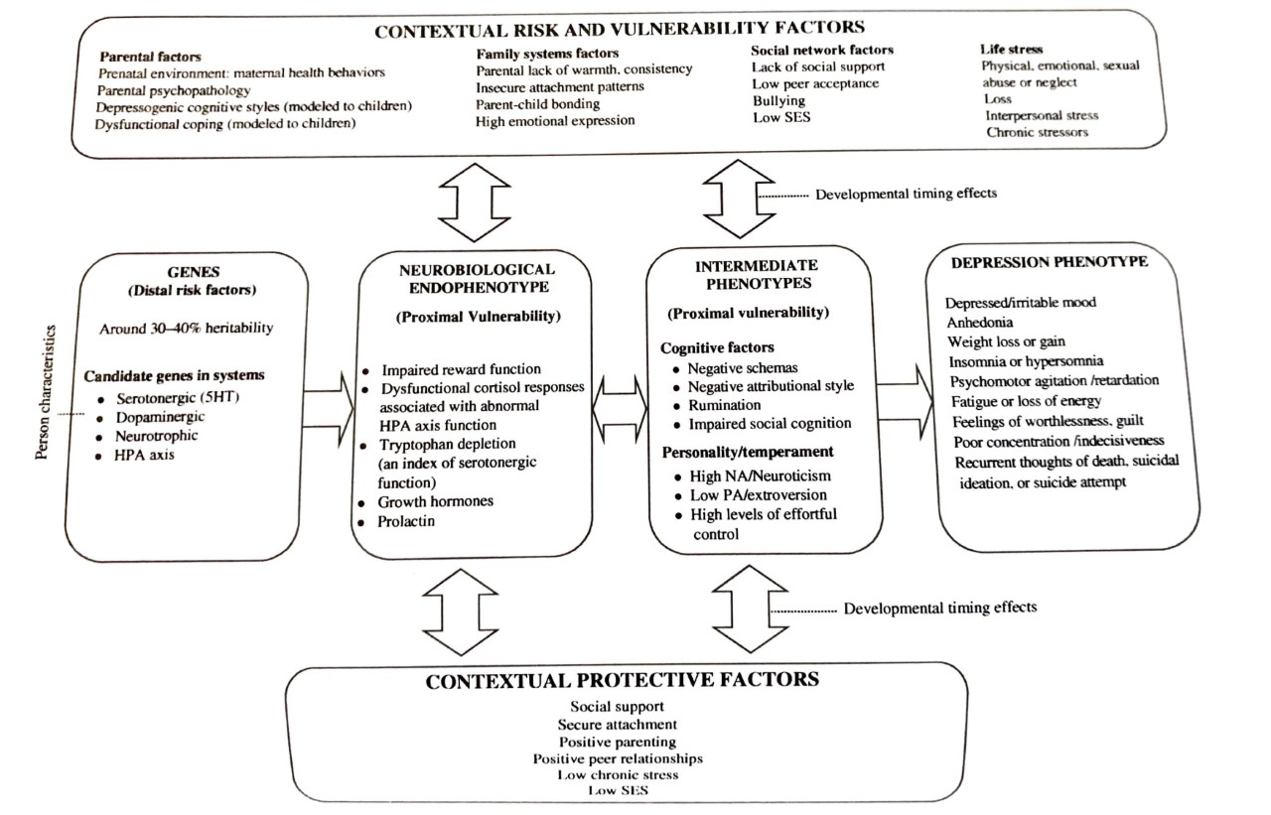

Anxiety Disorders
The distinction between normal anxiety/fear and a clinically significant anxiety disorder is
- Frequency
- Severity
- Duration
- Impact on functioning
- Degree of distress
  - Children with anxiety show fear that is disproportionate to the stimuli
    - Avoid feared stimuli, cry, tantrums, clinginess, freeze response

Separation Anxiety Disorder
Diagnostic Criteria 309.21 (F93.0)
A. Developmentally inappropriate and excessive fear or anxiety concerning separation from those to whom the individual is attached, as evidenced by at least three of the following:
1. Recurrent excessive distress when anticipating or experiencing separation from home or from major attachment figures.
2. Persistent and excessive worry about losing major attachment figures or about possible harm to them, such as illness, injury, disasters, or death.
3. Persistent and excessive worry about experiencing an untoward event (e.g., getting lost, being kidnapped, having an accident, becoming ill) that causes separation from a major attachment figure.
4. Persistent reluctance or refusal to go out, away from home, to school, to work, or elsewhere because of fear of separation.
5. Persistent and excessive fear of or reluctance about being alone or without major attachment figures at home or in other settings.
6. Persistent reluctance or refusal to sleep away from home or to go to sleep without being near a major attachment figure.
7. Repeated nightmares involving the theme of separation.
8. Repeated complaints of physical symptoms (e.g., headaches, stomachaches, nausea, vomiting) when separation from major attachment figures occurs or is anticipated.
B. The fear, anxiety, or avoidance is persistent, lasting at least 4 weeks in children and adolescents and typically 6 months or more in adults.
C. The disturbance causes clinically significant distress or impairment in social, academic, occupational, or other important areas of functioning.
D. The disturbance is not better explained by another mental disorder, such as refusing to leave home because of excessive resistance to change in autism spectrum disorder; delusions or hallucinations concerning separation in psychotic disorders; refusal to go outside without a trusted companion in agoraphobia; worries about ill health or other harm befalling significant others in generalized anxiety disorder; or concerns about having an illness in illness anxiety disorder.

Selective Mutism
Diagnostic Criteria 313.23 (F94.0)
A. Consistent failure to speak in specific social situations in which there is an expectation for speaking (e.g., at school) despite speaking in other situations.
B. The disturbance interferes with educational or occupational achievement or with social communication.
C. The duration of the disturbance is at least 1 month (not limited to the first month of school).
D. The failure to speak is not attributable to a lack of knowledge of, or comfort with, the spoken language required in the social situation.
E. The disturbance is not better explained by a communication disorder (e.g., childhood onset fluency disorder) and does not occur exclusively during the course of autism spectrum disorder, schizophrenia, or another psychotic disorder.

Obsessive-Compulsive Disorder
Diagnostic Criteria 300.3 (F42)
A. Presence of obsessions, compulsions, or both:
Obsessions are defined by (1) and (2):
1. Recurrent and persistent thoughts, urges, or images that are experienced, at some time during the disturbance, as intrusive and unwanted, and that in most individuals cause marked anxiety or distress.
2. The individual attempts to ignore or suppress such thoughts, urges, or images, or to neutralize them with some other thought or action (i.e., by performing a compulsion).
Compulsions are defined by (1) and (2):
1. Repetitive behaviors (e.g., hand washing, ordering, checking) or mental acts (e.g., praying, counting, repeating words silently) that the individual feels driven to perform in response to an obsession or according to rules that must be applied rigidly.
2. The behaviors or mental acts are aimed at preventing or reducing anxiety or distress, or preventing some dreaded event or situation; however, these behaviors or mental acts are not connected in a realistic way with what they are designed to neutralize or prevent or are clearly excessive. Note: Young children may not be able to articulate the aims of these behaviors or mental acts.
B. The obsessions or compulsions are time-consuming (e.g., take more than 1 hour per day) or cause clinically significant distress or impairment in social, occupational, or other important areas of functioning.
C. The obsessive-compulsive symptoms are not attributable to the physiological effects of a substance (e.g., a drug of abuse, a medication) or another medical condition.
D. The disturbance is not better explained by the symptoms of another mental disorder (e.g., excessive worries, as in generalized anxiety disorder; preoccupation with appearance, as in body dysmorphic disorder; difficulty discarding or parting with possessions, as in hoarding disorder; hair pulling, as in trichotillomania [hair-pulling disorder]; skin picking, as in excoriation [skin-picking] disorder; stereotypies, as in stereotypic movement disorder; ritualized eating behavior, as in eating disorders; preoccupation with substances or gambling, as in substance-related and addictive disorders; preoccupation with having an illness, as in illness anxiety disorder; sexual urges or fantasies, as in paraphilic disorders; impulses, as in disruptive, impulse-control, and conduct disorders; guilty ruminations, as in major depressive disorder; thought insertion or delusional preoccupations, as in schizophrenia spectrum and other psychotic disorders; or repetitive patterns of behavior, as in autism spectrum disorder).
Specify if:
With good or fair insight: The individual recognizes that obsessive-compulsive disorder beliefs are definitely or probably not true or that they may or may not be true.
With poor insight: The individual thinks obsessive-compulsive disorder beliefs are probably true. With absent insight/delusional beliefs: The individual is completely convinced that obsessive-compulsive disorder beliefs are true.
Specify if:
Tic-related: The individual has a current or past history of a tic disorder.

Generalized Anxiety Disorder
Diagnostic Criteria 300.02 (F41.1)
A. Excessive anxiety and worry (apprehensive expectation), occurring more days than not for at least 6 months, about a number of events or activities (such as work or school performance).
B. The individual finds it difficult to control the worry.
C. The anxiety and worry are associated with three (or more) of the following six symptoms (with at least some symptoms having been present for more days than not for the past 6 months): Note: Only one item is required in children.
1. Restlessness or feeling keyed up or on edge.
2. Being easily fatigued.
3. Difficulty concentrating or mind going blank.
4. Irritability.
5. Muscle tension.
6. Sleep disturbance (difficulty falling or staying asleep, or restless, unsatisfying sleep).
D. The anxiety, worry, or physical symptoms cause clinically significant distress or impairment in social, occupational, or other important areas of functioning.
E. The disturbance is not attributable to the physiological effects of a substance (e.g., a drug of abuse, a medication) or another medical condition (e.g., hyperthyroidism).
F. The disturbance is not better explained by another mental disorder (e.g., anxiety or worry about having panic attacks in panic disorder, negative evaluation in social anxiety disorder [social phobia], contamination or other obsessions in obsessive-compulsive disorder, separation from attachment figures in separation anxiety disorder, reminders of traumatic events in posttraumatic stress disorder, gaining weight in anorexia nervosa, physical complaints in somatic symptom disorder, perceived appearance flaws in body dysmorphic disorder, having a serious illness in illness anxiety disorder, or the content of delusional beliefs in schizophrenia or delusional disorder).

Social Anxiety Disorder (Social Phobia)

A. Marked fear or anxiety about one or more social situations in which the individual is exposed to possible scrutiny by others. Examples include social interactions (e.g., having a conversation, meeting unfamiliar people), being observed (e.g., eating or drinking), and performing in front of others (e.g., giving a speech). Note: In children, the anxiety must occur in peer settings and not just during interactions with adults.
B. The individual fears that he or she will act in a way or show anxiety symptoms that will be negatively evaluated (i.e., will be humiliating or embarrassing; will lead to rejection or offend others).
C. The social situations almost always provoke fear or anxiety. Note: In children, the fear or anxiety may be expressed by crying, tantrums, freezing, clinging, shrinking, or failing to speak in social situations.
D. The social situations are avoided or endured with intense fear or anxiety.
E. The fear or anxiety is out of proportion to the actual threat posed by the social situation and to the sociocultural context.
F. The fear, anxiety, or avoidance is persistent, typically lasting for 6 months or more.
G. The fear, anxiety, or avoidance causes clinically significant distress or impairment in social, occupational, or other important areas of functioning.
H. The fear, anxiety, or avoidance is not attributable to the physiological effects of a substance (e.g., a drug of abuse, a medication) or another medical condition.
I. The fear, anxiety, or avoidance is not better explained by the symptoms of another mental disorder, such as panic disorder, body dysmorphic disorder, or autism spectrum disorder. J. If another medical condition (e.g., Parkinson’s disease, obesity, disfigurement from burns or injury) is present, the fear, anxiety, or avoidance is clearly unrelated or is excessive.
Specify if: Performance only: If the fear is restricted to speaking or performing in public.

Prevalence
- Anxiety disorders are the most common disorder in children/teens
  - Typically arises in middle childhood, about 30% of youth will develop an anxiety disorder by the age of 18
- 7-11% of children with anxiety disorders will develop it before the age of 5
- Asian and Latinx children more likely to endorse somatic symptoms
- Black children endorse higher levels of anxiety
  - Mixed finding on prevalence of anxiety between groups
- Highly comorbid with mood disorders and substance use
  - Anxiety in children may be a warning sign of worse things to come if left untreated

Developmental Course
- Historically, childhood anxiety was viewed as something to “grow out of.” Contemporary research has indicated that childhood anxiety is often predictive of future psychopathology
- Homotypic = social anxiety disorder in children predicts SAD in adulthood.
  - Homotypic= (stability in the same or similar behavioral responses over time; that is, the same disorder predicts itself over time)
- Heterotypic = GAD in childhood predicts depression in adulthood.
  - Heterotypic= (stability of an underlying construct that manifests different across time as a result of developmental changes; that is, different disorders predict one another over time).

Anxiety Sensitivity
- Danger expectancies: ability of a feared stimuli to signal danger in the environment
  - EX sight of dog causes fear of being bitten
- Anxiety expectancy: ability of a particular stimuli to fear anxiety
  - EX sight of dog causes child to fear going near it, as they expect becoming overly anxious around the dog
- Anxiety sensitivity: cognitive-affective predisposition to interpret the sensations of anxiety as dangerous
  - Positive feedback look: child may interpret their anxiety symptoms (racing heart) as catastrophic and thus exacerbates their anxiety

Temperament
- Behavioral inhibition (general tendency to react cautiously and with restraint in new situation) is prevalent among children with anxiety
  - However, only a small portion of children with behavioral inhibition go onto develop an anxiety disorder
- Negative affectivity/emotionality increases risk of children to develop anxiety, particularly if exposed to adversity
- Effortful control (trait involving voluntary control of behaviors) is a protective factor

Developmental Model of Anxiety
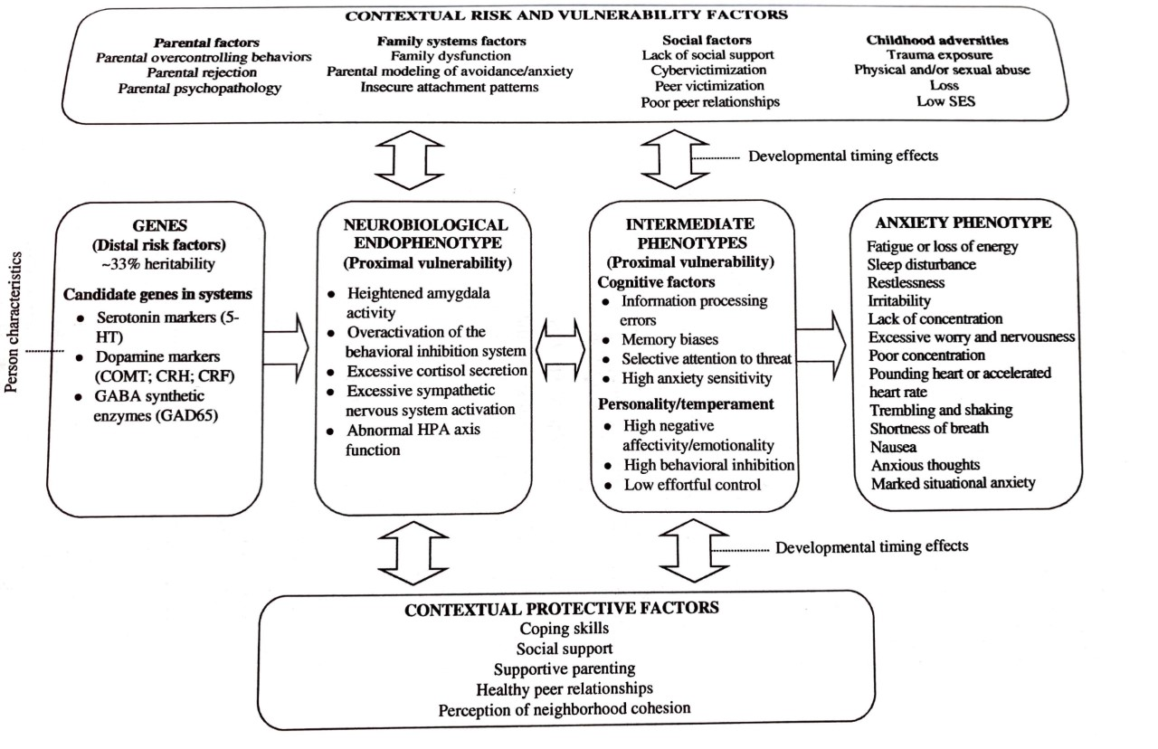
- 33% of variability in child anxiety is attributed to genetics
  - Genetic strength increases as children go into teen years
- Children of anxious parents 7x more likely
- Attention, memory, and interpretation biases (focus on negative, threatening stimuli)
- Insecure attachment is related to anxiety via poor emotion regulation
- Risk factors:
  - Parental overcontrolling (overprotection and intrusive behaviors) limits the child’s exposure to approaching fearful experiences and develop the ability to cope. These parental behaviors also teach the child that something is threatening
  - Parental rejection: reduced child’s ability to regulate negative emotions, which reduces ability to manage anxiety
  - Adverse experiences/trauma: interferes with developing typical stress system

Trauma-and Stressor-Related Disorders / Attachment-Related Disorders
Many DSM criteria for avoidance and numbing systems are not developmentally plausible (sense of foreshortened future) or are internal in quality thus hard to assess (avoidance of reminders)
  - Marked diminished in interests often looks like restricted play
  - That has been an ongoing call by the field of developmental psychology to construct a more appropriate trauma diagnosis for children

Reactive Attachment Disorder
Diagnostic Criteria 313.89 (F94.1)
A. A consistent pattern of inhibited, emotionally withdrawn behavior toward adult caregivers, manifested by both of the following:
1. The child rarely or minimally seeks comfort when distressed.
2. The child rarely or minimally responds to comfort when distressed.
B. A persistent social and emotional disturbance characterized by at least two of the following:
1. Minimal social and emotional responsiveness to others.
2. Limited positive affect.
3. Episodes of unexplained irritability, sadness, or fearfulness that are evident even during nonthreatening interactions with adult caregivers.
C. The child has experienced a pattern of extremes of insufficient care as evidenced by at least one of the following:
1. Social neglect or deprivation in the form of persistent lack of having basic emotional needs for comfort, stimulation, and affection met by caregiving adults. 266 Trauma- and Stressor-Related Disorders
2. Repeated changes of primary caregivers that limit opportunities to form stable attachments (e.g., frequent changes in foster care).
3. Rearing in unusual settings that severely limit opportunities to form selective attachments (e.g., institutions with high child-to-caregiver ratios).
D. The care in Criterion C is presumed to be responsible for the disturbed behavior in Criterion A (e.g., the disturbances in Criterion A began following the lack of adequate care in Criterion C).
E. The criteria are not met for autism spectrum disorder. F. The disturbance is evident before age 5 years.
G. The child has a developmental age of at least 9 months.
Specify if:
Persistent: The disorder has been present for more than 12 months.
Specify current severity: Reactive attachment disorder is specified as severe when a child exhibits all symptoms of the disorder, with each symptom manifesting at relatively high levels.

Disinhibited Social Engagement Disorder
Diagnostic Criteria 313.89 (F94.2)
A. A pattern of behavior in which a child actively approaches and interacts with unfamiliar adults and exhibits at least two of the following:
1. Reduced or absent reticence in approaching and interacting with unfamiliar adults.
2. Overly familiar verbal or physical behavior (that is not consistent with culturally sanctioned and with age-appropriate social boundaries).
3. Diminished or absent checking back with adult caregiver after venturing away, even in unfamiliar settings.
4. Willingness to go off with an unfamiliar adult with minimal or no hesitation.
B. The behaviors in Criterion A are not limited to impulsivity (as in attention-deficit/hyperactivity disorder) but include socially disinhibited behavior.
C. The child has experienced a pattern of extremes of insufficient care as evidenced by at least one of the following:
1. Social neglect or deprivation in the form of persistent lack of having basic emotional needs for comfort, stimulation, and affection met by caregiving adults.
2. Repeated changes of primary caregivers that limit opportunities to form stable attachments (e.g., frequent changes in foster care).
3. Rearing in unusual settings that severely limit opportunities to form selective attachments (e.g., institutions with high child-to-caregiver ratios). Disinhibited Social Engagement Disorder 269
D. The care in Criterion C is presumed to be responsible for the disturbed behavior in Criterion A (e.g., the disturbances in Criterion A began following the pathogenic care in Criterion C).
E. The child has a developmental age of at least 9 months.
Specify if:
Persistent: The disorder has been present for more than 12 months.
Specify current severity: Disinhibited social engagement disorder is specified as severe when the child exhibits all symptoms of the disorder, with each symptom manifesting at relatively high levels.

Posttraumatic Stress Disorder
Diagnostic Criteria 309.81 (F43.10):
Posttraumatic Stress Disorder Note: The following criteria apply to adults, adolescents, and children older than 6 years.
A. Exposure to actual or threatened death, serious injury, or sexual violence in one (or more) of the following ways:
1. Directly experiencing the traumatic event(s).
2. Witnessing, in person, the event(s) as it occurred to others.
3. Learning that the traumatic event(s) occurred to a close family member or close friend. In cases of actual or threatened death of a family member or friend, the event(s) must have been violent or accidental.
4. Experiencing repeated or extreme exposure to aversive details of the traumatic event(s) (e.g., first responders collecting human remains; police officers repeatedly exposed to details of child abuse).
Note: Criterion A4 does not apply to exposure through electronic media, television, movies, or pictures, unless this exposure is work related.
B. Presence of one (or more) of the following intrusion symptoms associated with the traumatic event(s), beginning after the traumatic event(s) occurred:
1. Recurrent, involuntary, and intrusive distressing memories of the traumatic event(s). Note: In children older than 6 years, repetitive play may occur in which themes or aspects of the traumatic event(s) are expressed.
2. Recurrent distressing dreams in which the content and/or affect of the dream are related to the traumatic event(s). Note: In children, there may be frightening dreams without recognizable content.
3. Dissociative reactions (e.g., flashbacks) in which the individual feels or acts as if the traumatic event(s) were recurring. (Such reactions may occur on a continuum, with the most extreme expression being a complete loss of awareness of present surroundings.) Note: In children, trauma-specific reenactment may occur in play.
4. Intense or prolonged psychological distress at exposure to internal or external cues that symbolize or resemble an aspect of the traumatic event(s).
5. Marked physiological reactions to internal or external cues that symbolize or resemble an aspect of the traumatic event(s).
C. Persistent avoidance of stimuli associated with the traumatic event(s), beginning after the traumatic event(s) occurred, as evidenced by one or both of the following:
1. Avoidance of or efforts to avoid distressing memories, thoughts, or feelings about or closely associated with the traumatic event(s).
2. Avoidance of or efforts to avoid external reminders (people, places, conversations, activities, objects, situations) that arouse distressing memories, thoughts, or feelings about or closely associated with the traumatic event(s).
D. Negative alterations in cognitions and mood associated with the traumatic event(s), beginning or worsening after the traumatic event(s) occurred, as evidenced by two (or more) of the following:
1. Inability to remember an important aspect of the traumatic event(s) (typically due to dissociative amnesia and not to other factors such as head injury, alcohol, or drugs).
2. Persistent and exaggerated negative beliefs or expectations about oneself, others, or the world (e.g., “I am bad,” “No one can be trusted,” “The world is completely dangerous,” “My whole nervous system is permanently ruined”).
3. Persistent, distorted cognitions about the cause or consequences of the traumatic event(s) that lead the individual to blame himself/herself or others.
4. Persistent negative emotional state (e.g., fear, horror, anger, guilt, or shame).
5. Markedly diminished interest or participation in significant activities.
6. Feelings of detachment or estrangement from others.
7. Persistent inability to experience positive emotions (e.g., inability to experience happiness, satisfaction, or loving feelings).
E. Marked alterations in arousal and reactivity associated with the traumatic event(s), beginning or worsening after the traumatic event(s) occurred, as evidenced by two (or more) of the following:
1. Irritable behavior and angry outbursts (with little or no provocation) typically expressed as verbal or physical aggression toward people or objects.
2. Reckless or self-destructive behavior.
3. Hypervigilance.
4. Exaggerated startle response.
5. Problems with concentration.
6. Sleep disturbance (e.g., difficulty falling or staying asleep or restless sleep).
F. Duration of the disturbance (Criteria B, C, D, and E) is more than 1 month.
G. The disturbance causes clinically significant distress or impairment in social, occupational, or other important areas of functioning.
H. The disturbance is not attributable to the physiological effects of a substance (e.g., medication, alcohol) or another medical condition.
Specify whether:
With dissociative symptoms: The individual’s symptoms meet the criteria for posttraumatic stress disorder, and in addition, in response to the stressor, the individual experiences persistent or recurrent symptoms of either of the following:
1. Depersonalization: Persistent or recurrent experiences of feeling detached from, and as if one were an outside observer of, one’s mental processes or body (e.g., feeling as though one were in a dream; feeling a sense of unreality of self or body or of time moving slowly).
2. Derealization: Persistent or recurrent experiences of unreality of surroundings (e.g., the world around the individual is experienced as unreal, dreamlike, distant, or distorted).
Note: To use this subtype, the dissociative symptoms must not be attributable to the physiological effects of a substance (e.g., blackouts, behavior during alcohol intoxication) or another medical condition (e.g., complex partial seizures).
Specify if: With delayed expression: If the full diagnostic criteria are not met until at least 6 months after the event (although the onset and expression of some symptoms may be immediate).
Posttraumatic Stress Disorder for Children 6 Years and Younger:
A. In children 6 years and younger, exposure to actual or threatened death, serious injury, or sexual violence in one (or more) of the following ways:
1. Directly experiencing the traumatic event(s).
2. Witnessing, in person, the event(s) as it occurred to others, especially primary caregivers.
Note: Witnessing does not include events that are witnessed only in electronic media, television, movies, or pictures. 3. Learning that the traumatic event(s) occurred to a parent or caregiving figure.
B. Presence of one (or more) of the following intrusion symptoms associated with the traumatic event(s), beginning after the traumatic event(s) occurred:
1. Recurrent, involuntary, and intrusive distressing memories of the traumatic event(s). Note: Spontaneous and intrusive memories may not necessarily appear distressing and may be expressed as play reenactment.
2. Recurrent distressing dreams in which the content and/or affect of the dream are related to the traumatic event(s). Note: It may not be possible to ascertain that the frightening content is related to the traumatic event.
3. Dissociative reactions (e.g., flashbacks) in which the child feels or acts as if the traumatic event(s) were recurring. (Such reactions may occur on a continuum, with the most extreme expression being a complete loss of awareness of present surroundings.) Such trauma-specific reenactment may occur in play.
4. Intense or prolonged psychological distress at exposure to internal or external cues that symbolize or resemble an aspect of the traumatic event(s).
5. Marked physiological reactions to reminders of the traumatic event(s).
C. One (or more) of the following symptoms, representing either persistent avoidance of stimuli associated with the traumatic event(s) or negative alterations in cognitions and mood associated with the traumatic event(s), must be present, beginning after the event(s) or worsening after the event(s):
Persistent Avoidance of Stimuli
1. Avoidance of or efforts to avoid activities, places, or physical reminders that arouse recollections of the traumatic event(s).
2. Avoidance of or efforts to avoid people, conversations, or interpersonal situations that arouse recollections of the traumatic event(s).
Negative Alterations in Cognitions
3. Substantially increased frequency of negative emotional states (e.g., fear, guilt, sadness, shame, confusion).
4. Markedly diminished interest or participation in significant activities, including constriction of play.
5. Socially withdrawn behavior.
6. Persistent reduction in expression of positive emotions.
D. Alterations in arousal and reactivity associated with the traumatic event(s), beginning or worsening after the traumatic event(s) occurred, as evidenced by two (or more) of the following:
1. Irritable behavior and angry outbursts (with little or no provocation) typically expressed as verbal or physical aggression toward people or objects (including extreme temper tantrums).
2. Hypervigilance.
3. Exaggerated startle response.
4. Problems with concentration.
5. Sleep disturbance (e.g., difficulty falling or staying asleep or restless sleep).
E. The duration of the disturbance is more than 1 month.
F. The disturbance causes clinically significant distress or impairment in relationships with parents, siblings, peers, or other caregivers or with school behavior.
G. The disturbance is not attributable to the physiological effects of a substance (e.g., medication or alcohol) or another medical condition.
Specify whether:
With dissociative symptoms: The individual’s symptoms meet the criteria for posttraumatic stress disorder, and the individual experiences persistent or recurrent symptoms of either of the following:
1. Depersonalization: Persistent or recurrent experiences of feeling detached from, and as if one were an outside observer of, one’s mental processes or body (e.g., feeling as though one were in a dream; feeling a sense of unreality of self or body or of time moving slowly).
2. Derealization: Persistent or recurrent experiences of unreality of surroundings (e.g., the world around the individual is experienced as unreal, dreamlike, distant, or distorted).
Note: To use this subtype, the dissociative symptoms must not be attributable to the physiological effects of a substance (e.g., blackouts) or another medical condition (e.g., complex partial seizures).
Specify if: With delayed expression: If the full diagnostic criteria are not met until at least 6 months after the event (although the onset and expression of some symptoms may be immediate).

Acute Stress Disorder
Diagnostic Criteria 308.3 (F43.0)
A. Exposure to actual or threatened death, serious injury, or sexual violation in one (or more) of the following ways:
1. Directly experiencing the traumatic event(s).
2. Witnessing, in person, the event(s) as it occurred to others.
3. Learning that the event(s) occurred to a close family member or close friend.
Note: In cases of actual or threatened death of a family member or friend, the event(s) must have been violent or accidental.
4. Experiencing repeated or extreme exposure to aversive details of the traumatic event(s) (e.g., first responders collecting human remains, police officers repeatedly exposed to details of child abuse).
Note: This does not apply to exposure through electronic media, television, movies, or pictures, unless this exposure is work related.
B. Presence of nine (or more) of the following symptoms from any of the five categories of intrusion, negative mood, dissociation, avoidance, and arousal, beginning or worsening after the traumatic event(s) occurred:
Intrusion Symptoms
1. Recurrent, involuntary, and intrusive distressing memories of the traumatic event(s).
Note: In children, repetitive play may occur in which themes or aspects of the traumatic event(s) are expressed.
2. Recurrent distressing dreams in which the content and/or affect of the dream are related to the event(s). Note: In children, there may be frightening dreams without recognizable content.
3. Dissociative reactions (e.g., flashbacks) in which the individual feels or acts as if the traumatic event(s) were recurring. (Such reactions may occur on a continuum, with the most extreme expression being a complete loss of awareness of present surroundings.)
Note: In children, trauma-specific reenactment may occur in play.
4. Intense or prolonged psychological distress or marked physiological reactions in response to internal or external cues that symbolize or resemble an aspect of the traumatic event(s).
Negative Mood
5. Persistent inability to experience positive emotions (e.g., inability to experience happiness, satisfaction, or loving feelings).
Dissociative Symptoms
6. An altered sense of the reality of one’s surroundings or oneself (e.g., seeing oneself from another’s perspective, being in a daze, time slowing).
7. Inability to remember an important aspect of the traumatic event(s) (typically due to dissociative amnesia and not to other factors such as head injury, alcohol, or drugs).
Avoidance Symptoms
8. Efforts to avoid distressing memories, thoughts, or feelings about or closely associated with the traumatic event(s).
9. Efforts to avoid external reminders (people, places, conversations, activities, objects, situations) that arouse distressing memories, thoughts, or feelings about or closely associated with the traumatic event(s).
Arousal Symptoms
10. Sleep disturbance (e.g., difficulty falling or staying asleep, restless sleep).
11. Irritable behavior and angry outbursts (with little or no provocation), typically expressed as verbal or physical aggression toward people or objects.
12. Hypervigilance.
13. Problems with concentration.
14. Exaggerated startle response.
C. Duration of the disturbance (symptoms in Criterion B) is 3 days to 1 month after trauma exposure. Note: Symptoms typically begin immediately after the trauma, but persistence for at least 3 days and up to a month is needed to meet disorder criteria.
D. The disturbance causes clinically significant distress or impairment in social, occupational, or other important areas of functioning.
E. The disturbance is not attributable to the physiological effects of a substance (e.g., medication or alcohol) or another medical condition (e.g., mild traumatic brain injury) and is not better explained by brief psychotic disorder.

Adjustment Disorder
Diagnostic Criteria
A. The development of emotional or behavioral symptoms in response to an identifiable stressor(s) occurring within 3 months of the onset of the stressor(s).
B. These symptoms or behaviors are clinically significant, as evidenced by one or both of the following:
1. Marked distress that is out of proportion to the severity or intensity of the stressor, taking into account the external context and the cultural factors that might influence symptom severity and presentation.
2. Significant impairment in social, occupational, or other important areas of functioning.
C. The stress-related disturbance does not meet the criteria for another mental disorder and is not merely an exacerbation of a preexisting mental disorder.
D. The symptoms do not represent normal bereavement.
E. Once the stressor or its consequences have terminated, the symptoms do not persist for more than an additional 6 months.
Specify whether:
309.0 (F43.21) With depressed mood: Low mood, tearfulness, or feelings of hopelessness are predominant.
309.24 (F43.22) With anxiety: Nervousness, worry, jitteriness, or separation anxiety is predominant.
309.28 (F43.23) With mixed anxiety and depressed mood: A combination of depression and anxiety is predominant.
309.3 (F43.24) With disturbance of conduct: Disturbance of conduct is predominant.
309.4 (F43.25) With mixed disturbance of emotions and conduct: Both emotional symptoms (e.g., depression, anxiety) and a disturbance of conduct are predominant.
309.9 (F43.20) Unspecified: For maladaptive reactions that are not classifiable as one of the specific subtypes of adjustment disorder

Developmental Models and Mechanisms of Stress
- Sensitive period model: period in development in which certain stimulus/input is necessary for development to continue or (more appropriate for developmental psychology) a time frame in which there is increased susceptibility or opportunity for development.
  - Opposed to “critical period”
  - Sensitive period implied less rigid time boundaries and less severe consequences
  - Imply that interventions outside of time would not be effective/less effective
    - Less severe consequences for counseling vs medical interventions
      - Because of plasticity
      - But still relevant, for example child self-concept development. Windows may be wider
- Developmental programming: fetal experiences can cause adaptive responses to environment that persist throughout development
  - Example: maternal stress during pregnancy
- Life Span Development/ Cumulative effects model: individual differences in psych development occur from combo of unique risk and protective factors and their accumulation throughout life.

Other models:
  - Sleeper effect: effects of a stressor may not be seen for years. There could either be a (1) cascade of intermediate effects between stressor and problem behavior or (2) biological underpinnings that cause behavior have not been developed (such as neural circuits related to depression)
  - Common misconceptions: (1) extensive maternal bonding immediately after birth is necessary for secure attachment and (2) developmental arrest

Stress Physiology: Hypothalamic-pituitary-adrenal (HPA) Axis
  - HPA axis can be modified by early stressors & have persisting effects into and beyond adolescents.
  - Particular attention to chronic stress vs short-term acute stressors
    - Chronic stress = glucocorticoid (regulate emotionally arousing experiences) resistance or glucocorticoid receptor (restore homeostasis after stressor) sensitivity. Results in hypo or hyper arousal to future stressors.
  - Allostatic load model: wear and tear of stress on the body over prolonged periods of time. Adaptive neuroendocrine responses to stress, if exposed chronically, have deleterious effects on body. Has wear and tear on HPA axis and related systems
- psychoneuroimmunology: connection between nervous system, immune system, and behavior. There is a close connection between immune systema and nervous systems.
  - Stress evokes immune response (evolutionary advantage)
  - Immune system has a role in neuroplasticity (i.e. PANDAS / pediatric autoimmune neuropsychiatric disorder associated with streptococcal infections – sudden onset of OCD-like symptoms and tics following step infection). Immune system shapes the brain by enacting cellular changes that alter synaptogenesis, modification, and pruning.
    - Children’s developing immune system may be more especially vulnerable to stress
- Genetic Models: BOTH genetic factors shape behaviors that increase exposure to environmental risks & genetics moderate effects of exposure.
  - Vulnerability perspective: Studies have found early emerging genetic-mediates effects, such as possession of a specific gene that makes a baby more vulnerable to a insecure attachment.
  - Susceptibility perspective: the same gene or genes may be associated with positive outcomes in certain environmental conditions and negative outcomes in another.

Prenatal Stress/ Child Anxiety Development
  - Prenatal stress can have a downstream effect on fetus’s stress response development & shapes fetal brain development.
    - Increased exposure to cortisol to a fetus is linked with physiological, immune, brain and behavioral changes.
      - Programming effects

Maternal Immune Activation
  - A significant immune insult during pregnancy may have neurodevelopmental effects on the child
    - Prolonged fever during pregnancy has been associated with ASD
- Early Intervention effects: catch up is possible!
  - Earlier intervention is most successful, if consistent through childhood
  - Improvements to child environment has been associated with persisting effects related to academic, behavioral, and emotional functioning (many studies related to foster placement/adoption after institutional placement in early life – implies a sensitive period framework for severe trauma may not be as applicable to less severe traumas)
  - Studies have not been able to fully assess for long term effects of parent training.
  - ***Few interventions as successful as changing the caregiving environment
    - Change in environment can mediate effects of chronic stress on HPA axis

Theories of attachment related to psychopathology

Control Systems Model of Behavioral Attachment Systems
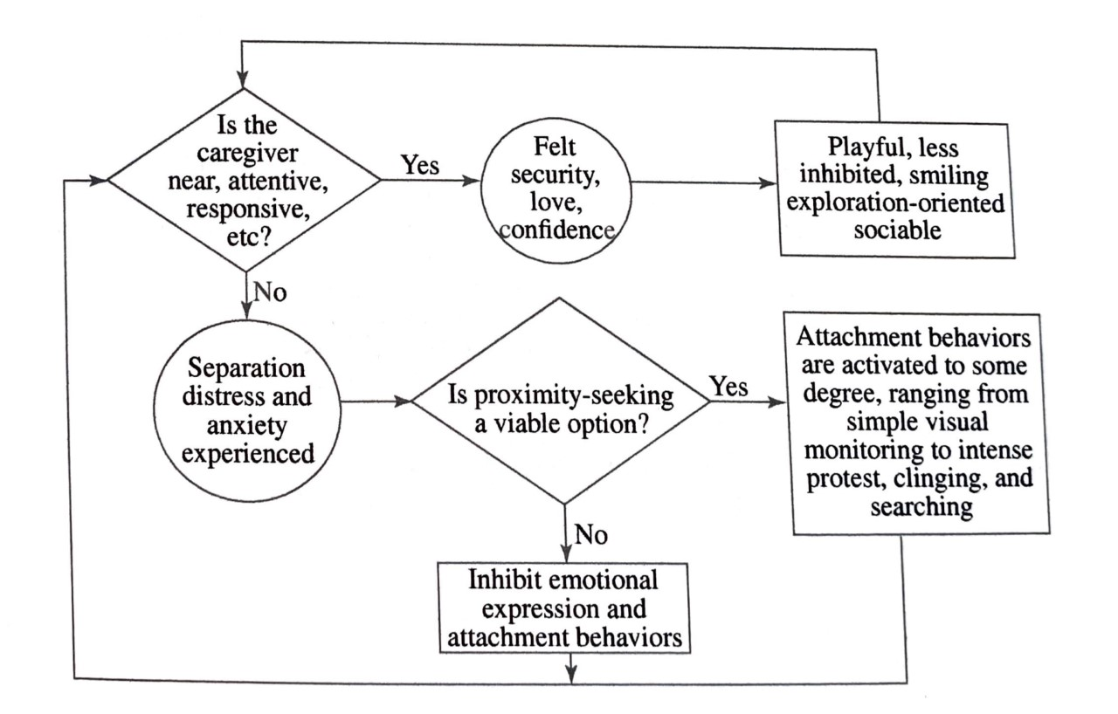

2-Dimensional Model of Attachment
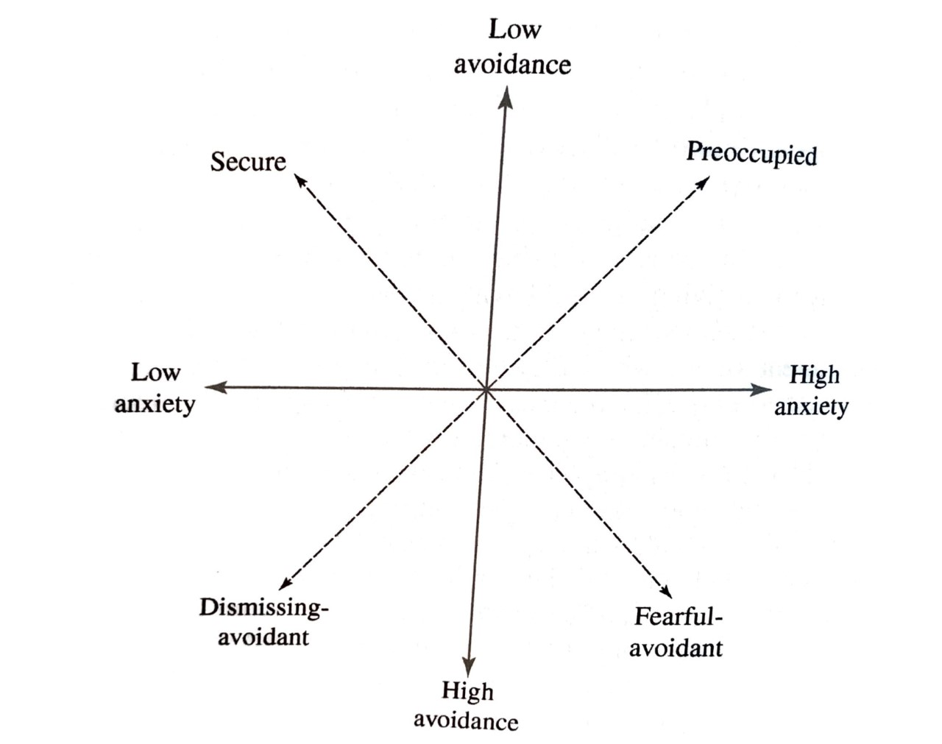

Secure Base Model
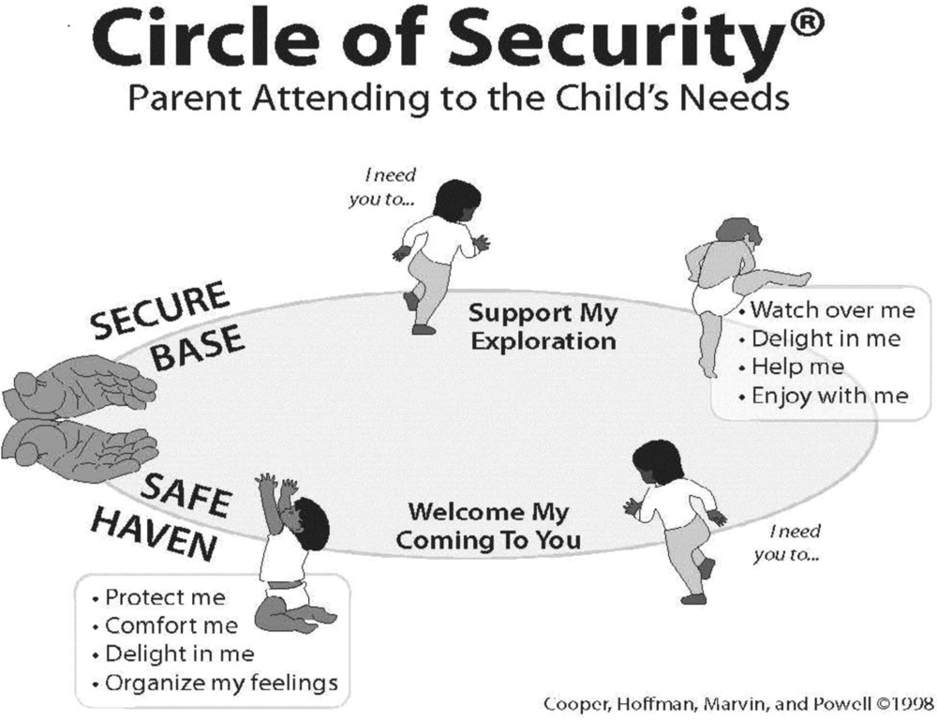

Development if Insecure Attachment
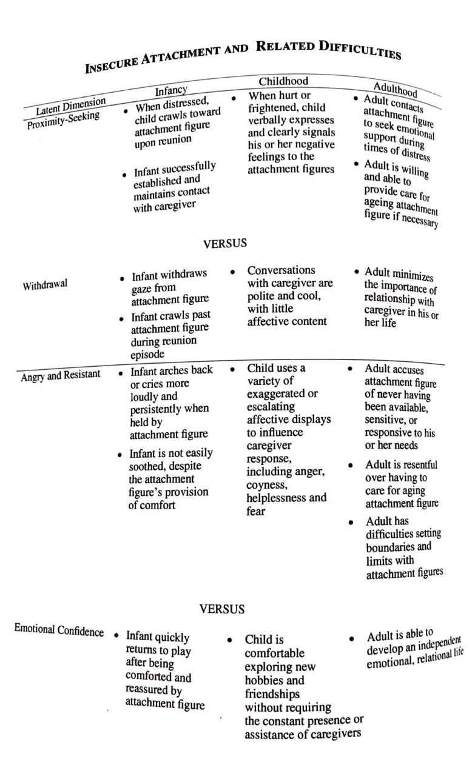

Developmental Model of Attachment
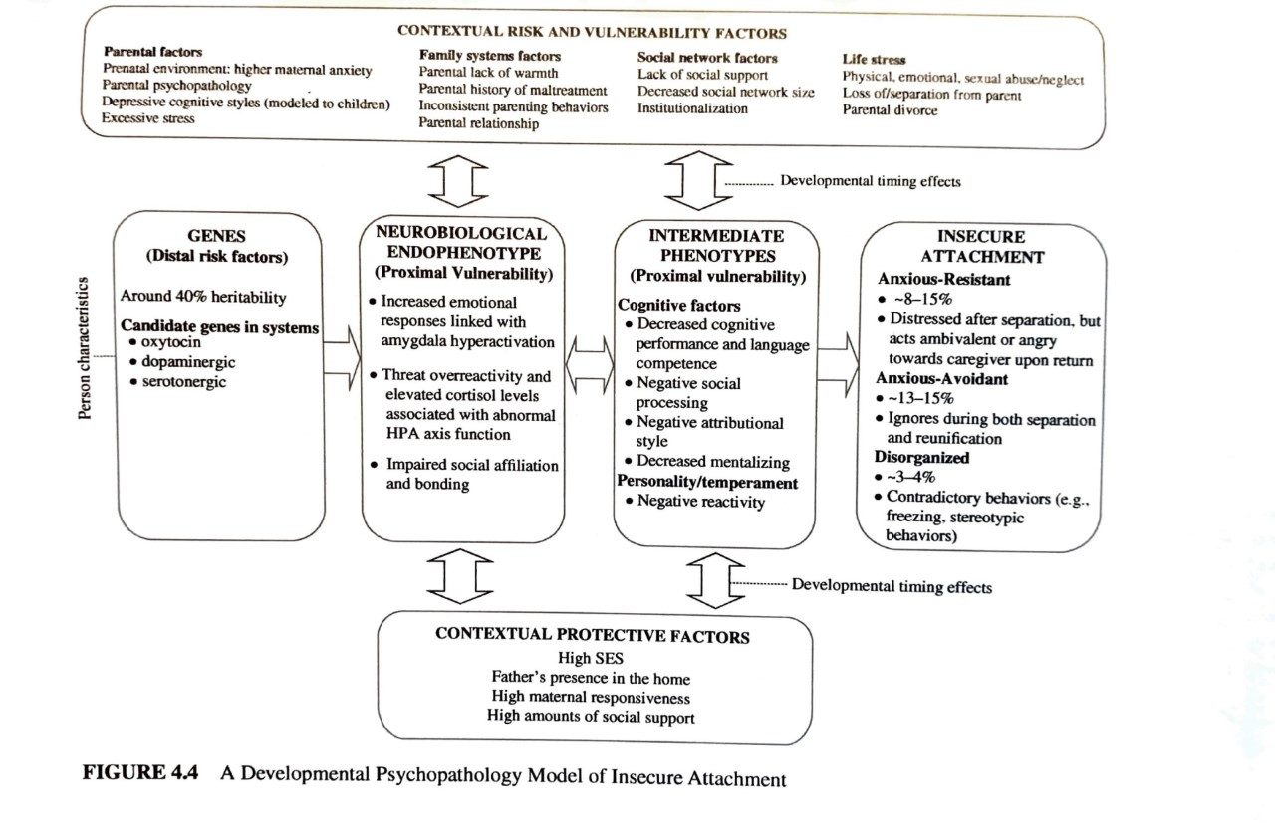

Intellectual Disability Disorder
Intelligence: “general mental ability that involves reasoning, problem solving, planning, thinking abstractly, comprehension, judgement, academic learning, and learning from experience.”
- DSM uses severity (mild, moderate, severe) rather than specifiers to designate adaptive functioning.
- DSM 5 emphasizes adaptive functioning when diagnosing (academics, social, practical) and how intelligence is applied to everyday life
  - Criteria is met if at least one domain of functioning is significantly impaired by low IQ

Diagnostic Criteria
Intellectual disability (intellectual developmental disorder) is a disorder with onset during the developmental period that includes both intellectual and adaptive functioning deficits in conceptual, social, and practical domains. The following three criteria must be met:
A. Deficits in intellectual functions, such as reasoning, problem solving, planning, abstract thinking, judgment, academic learning, and learning from experience, confirmed by both clinical assessment and individualized, standardized intelligence testing.
B. Deficits in adaptive functioning that result in failure to meet developmental and sociocultural standards for personal independence and social responsibility. Without ongoing support, the adaptive deficits limit functioning in one or more activities of daily life, such as communication, social participation, and independent living, across multiple environments, such as home, school, work, and community.
C. Onset of intellectual and adaptive deficits during the developmental period.
Note: The diagnostic term intellectual disability is the equivalent term for the ICD-11 diagnosis of intellectual developmental disorders. Although the term intellectual disability is used throughout this manual, both terms are used in the title to clarify relationships with other classification systems. Moreover, a federal statute in the United States (Public Law 111-256, Rosa’s Law) replaces the term mental retardation with intellectual disability, and research journals use the term intellectual disability. Thus, intellectual disability is the term in common use by medical, educational, and other professions and by the lay public and advocacy groups.
Specify current severity: 317 (F70) Mild 318.0 (F71) Moderate 318.1 (F72) Severe 318.2 (F73) Profound

Severity Level Chart:
Severity Level | Conceptual Domain | Social Domain | Practical Domain
mild | For preschool children, there may be no obvious conceptual differences. For school-age children and adults, there are difficulties in learning aca- demic skills involving reading, writing, arithmetic, time, or money, with support needed in one or more areas to meet age-related expectations. In adults, abstract thinking, executive function (i.e., planning, strategizing, priority setting, and cognitive flexibility), and short-term memory, as well as functional use of academic skills (e.g., reading, money management), are impaired. There is a somewhat concrete approach to problems and solutions compared with age-mates. | Compared with typically developing age- mates, the individual is immature in social interactions. For example, there may be difficulty in accurately perceiving peers’ social cues. Communication, conversation, and language are more concrete or immature than expected for age. There may be difficulties regulating emotion and behavior in age-appropriate fashion; these difficulties are noticed by peers in social situations. There is limited understanding of risk in social situations; social judgment is immature for age, and the person is at risk of being manipulated by others (gullibility). | The individual may function age-appropriately in personal care. Individuals need some support with complex daily living tasks in comparison to peers. In adulthood, supports typically involve grocery shop- ping, transportation, home and child-care organizing, nutritious food preparation, and banking and money management. Recreational skills resemble those of age-mates, although judgment related to well-being and organization around recreation requires support. In adulthood, competitive employment is often seen in jobs that do not emphasize conceptual skills. Individuals generally need support to make health care decisions and legal decisions, and to learn to perform a skilled vocation competently. Support is typically needed to raise a family.
Moderate | All through development, the individual’s conceptual skills lag markedly behind those of peers. For preschoolers, language and pre-academic skills develop slowly. For school-age children, progress in reading, writing, mathematics, and understanding of time and money occurs slowly across the school years and is markedly limited compared with that of peers. For adults, aca- demic skill development is typically at an elementary level, and support is required for all use of academic skills in work and personal life. Ongoing assistance on a daily basis is needed to complete conceptual tasks of day-to-day life, and others may take over these responsibilities fully for the individual. | The individual shows marked differences from peers in social and communicative behavior across development. Spoken language is typically a primary tool for social communication but is much less complex than that of peers. Capacity for relationships is evident in ties to family and friends, and the individual may have successful friendships across life and sometimes romantic relations in adulthood. However, individuals may not perceive or interpret social cues accurately. Social judgment and decision-making abilities are limited, and caretakers must assist the person with life decisions. Friendships with typically developing peers are often affected by communication or social limitations. Significant social and communicative support is needed in work settings for success. | The individual can care for personal needs involving eating, dressing, elimination, and hygiene as an adult, although an extended period of teaching and time is needed for the individual to become independent in these areas, and reminders may be needed. Similarly, participation in all household tasks can be achieved by adulthood, although an extended period of teaching is needed, and ongoing supports will typically occur for adult-level performance. Independent employment in jobs that require limited conceptual and communication skills can be achieved, but considerable support from co-workers, supervisors, and others is needed to manage social expectations, job complexities, and ancillary responsibilities such as scheduling, transportation, health benefits, and money management. A variety of recreational skills can be developed. These typically require additional supports and learning opportunities over an extended period of time. Maladaptive behavior is present in a significant minority and causes social problems.
Severe | Attainment of conceptual skills is limited. The individual generally has little understanding of written language or of concepts involving numbers, quantity, time, and money. Caretakers provide extensive supports for problem solving throughout life. | Spoken language is quite limited in terms of vocabulary and grammar. Speech may be single words or phrases and may be supplemented through augmentative means. Speech and communication are focused on the here and now within everyday events. Language is used for social communication more than for explication. Individuals understand simple speech and gestural communication. Relation- ships with family members and familiar others are a source of pleasure and help. | The individual requires support for all activities of daily living, including meals, dressing, bathing, and elimination. The individual requires supervision at all times. The individual cannot make responsible decisions regarding well-being of self or others. In adulthood, participation in tasks at home, recreation, and work requires ongoing support and assistance. Skill acquisition in all domains involves long- term teaching and ongoing support. Maladaptive behavior, including self-injury, is present in a significant minority.
Profound | Conceptual skills generally involve the physical world rather than symbolic processes. The individual may use objects in goal-directed fashion for self-care, work, and recreation. Certain visuospatial skills, such as matching and sorting based on physical characteristics, may be acquired. However, co-occurring motor and sensory impairments may prevent functional use of objects. | The individual has very limited understanding of symbolic communication in speech or gesture. He or she may understand some simple instructions or gestures. The individual expresses his or her own desires and emotions largely through nonverbal, non-symbolic communication. The individual enjoys relation- ships with well-known family members, caretakers, and familiar others, and initiates and responds to social interactions through gestural and emotional cues. Co-occurring sensory and physical impairments may pre- vent many social activities. | The individual is dependent on others for all aspects of daily physical care, health, and safety, although he or she may be able to participate in some of these activities as well. Individuals without severe physical impairments may assist with some daily work tasks at home, like carrying dishes to the table. Simple actions with objects may be the basis of participation in some vocational activities with high levels of ongoing sup- port. Recreational activities may involve, for example, enjoyment in listening to music, watching movies, going out for walks, or participating in water activities, all with the support of others. Co-occurring physical and sensory impairments are frequent barriers to participation (beyond watching) in home, recreational, and vocational activities. Maladaptive behavior is present in a significant minority

Limitations of the IDD Diagnosis
- Cut-off points are arbitrary and based in societal standards rather than science
  - Low scores on WISC/WAIS can be attained for other reasons/etiologies typically associated with IDD
  - Someone with an IQ of 71 (not diagnosed) is likely not functioning much differently than someone with an IQ of 69 (IDD)
    - May see “borderline IDD” in medical settings
    - Full-scale IQ is not as meaningful as scores on individual scales
- There are many etiologies of IDD & the population is very heterogeneous compared to other clinical populations (wider-range of features, etiologies, and trajectories)
  - Argues for reclassification of IDD based on unique features and etiology
- Cut off points and diagnostic criteria have changed considerably throughout the iterations of the DSM
- Disproportionately high number of children from marginalized communities have been historically diagnosed with mild ID, as IQ test are often not culturally relevant and underestimate their abilities
  - Emphasizes holistic approach and strong assessment of adaptive functioning rather than just solely basing diagnosis off of IQ score

Historical Perspectives
- 1960s-70s: Defect approach – ID (then called MR) was caused by a set of cognitive defects common to all people affected by it
  - Very monolithic, ignored vast amount of heterogeneity, discriminatory perspective.
    - Opposition to this theory Argues that those with ID are organized, adaptive, and integrated in their own right
      - Constructivist approach: child is an active agent in environment and is adapting with their given abilities
- Late 60s-70s Two-Group Approach – familial and organic IDD
  - Emphasized 2 etiological approaches to the development of ID
    - Cultural-Familial ID – caused by environment
      - Often mild-moderate ID
      - Conceptualized as those statistically near the low-end of the normal IQ distribution. Environmental effects exacerbated
      - Likely had at least 1 parent with a low IQ
      - Development on a normal trajectory, but slowed down
      - Similar structure hypothesis: would function equally as someone w/o ID who has the same mental age (not chronological age)
    - Organic ID – caused by biological factors
      - Conceptualized as severe ID with low adaptive functioning,
        - Need large amounts of support
        - “born with it”
- Concept of familial transmission of ID has been highly influential
  - Contributed to USA sterilization laws in early 1900s.
- 1980s: Call to expand beyond 2 approaches
  - Expand understanding of “organic” ID
    - Expand understanding of gene interactions that cause ID
    - Some theorists agued to that those with organize ID are organized, adaptive, and integrated in their own right
      - Previously thought to be relevant for those only with familial ID

Holistic / Contemporary Perspectives
- Ziegler identified characteristics common to people with mild-moderate ID, as an effect of living with their disorders: over-dependency, low self-esteem, wariness of others, low motivation, reinforcement seeking, more often using outer directedness (looking to others to see what to do in situations).
  - perceived as a natural outcome/adaptation for someone living with ID
- Large variation in language abilities and social competence among those with ID, particularly those with different genetic etiologies (fragile x, down syndrome, Prader-Willi), argues against monolithic approach

IDD & the family system
- Studies have identified negative effects on the family unit: parental stress, strain in romantic relationship, negative emotionality in parents, but also positive outcomes such as optimism
  - Timing of diagnosis associated with parental reaction
    - Early diagnosis found to relieve stress in parents of children with down syndrome
    - False negative diagnoses increase stress
  - Problem solving & positive reappraisal found to decrease stress compared to avoidance or escapism coping skills In parents
      - Mothers tend to find success in emotional support, father in instrumental support
  - Can affect attachment, as baby may not be reciprocating parents’ cues as expected.
    - Less shared joint attention
    - Cyclical pattern

Neuroscience Perspectives
- No clear connection between ID and brain physiology
- No consensus on how to treat based on neuroscience findings
- Research findings suggest different sensory processing among those with ID
  - Fragile X more sensitive to auditory input & have trouble habituating to repeated input
  - Fragile X different brain activation during research task
    - Suggest using more processing resources
  - Fragile X gaze avoidance
  - Down syndrome different brain activation during cognitive tasks
  - Down syndrome receptive language difficulties in passing listening task
  - Down syndrome poorer sensitivity to smell
  - Williams syndrome: hyper social and visuospatial deficits (trouble integrating parts to a whole)

Autism Spectrum Disorder

“If you’ve met one child with autism, then you’ve met one child with autism”
Diagnosis is very heterogeneous

Diagnostic Criteria
A. Persistent deficits in social communication and social interaction across multiple contexts, as manifested by the following, currently or by history (examples are illustrative, not exhaustive; see text):
1. Deficits in social-emotional reciprocity, ranging, for example, from abnormal social approach and failure of normal back-and-forth conversation; to reduced sharing of interests, emotions, or affect; to failure to initiate or respond to social interactions.
2. Deficits in nonverbal communicative behaviors used for social interaction, ranging, for example, from poorly integrated verbal and nonverbal communication; to abnormalities in eye contact and body language or deficits in understanding and use of gestures; to a total lack of facial expressions and nonverbal communication.
3. Deficits in developing, maintaining, and understanding relationships, ranging, for example, from difficulties adjusting behavior to suit various social contexts; to difficulties in sharing imaginative play or in making friends; to absence of interest in peers.
Specify current severity: Severity is based on social communication impairments and restricted, repetitive patterns of behavior.
B. Restricted, repetitive patterns of behavior, interests, or activities, as manifested by at least two of the following, currently or by history (examples are illustrative, not exhaustive; see text):
1. Stereotyped or repetitive motor movements, use of objects, or speech (e.g., simple motor stereotypies, lining up toys or flipping objects, echolalia, idiosyncratic phrases).
2. Insistence on sameness, inflexible adherence to routines, or ritualized patterns of verbal or nonverbal behavior (e.g., extreme distress at small changes, difficulties with transitions, rigid thinking patterns, greeting rituals, need to take same route or eat same food every day).
3. Highly restricted, fixated interests that are abnormal in intensity or focus (e.g., strong attachment to or preoccupation with unusual objects, excessively circumscribed or perseverative interests).
4. Hyper- or hyporeactivity to sensory input or unusual interest in sensory aspects of the environment (e.g., apparent indifference to pain/temperature, adverse response to specific sounds or textures, excessive smelling or touching of objects, visual fascination with lights or movement).
Specify current severity: Severity is based on social communication impairments and restricted, repetitive patterns of behavior.
C. Symptoms must be present in the early developmental period (but may not become fully manifest until social demands exceed limited capacities or may be masked by learned strategies in later life).
D. Symptoms cause clinically significant impairment in social, occupational, or other important areas of current functioning.
E. These disturbances are not better explained by intellectual disability (intellectual developmental disorder) or global developmental delay. Intellectual disability and autism spectrum disorder frequently co-occur; to make comorbid diagnoses of autism spectrum disorder and intellectual disability, social communication should be below that expected for general developmental level.
Note: Individuals with a well-established DSM-IV diagnosis of autistic disorder, Asperger’s disorder, or pervasive developmental disorder not otherwise specified should be given the diagnosis of autism spectrum disorder. Individuals who have marked deficits in social communication, but whose symptoms do not otherwise meet criteria for autism spectrum disorder, should be evaluated for social (pragmatic) communication disorder.
Specify if:
With or without accompanying intellectual impairment
With or without accompanying language impairment
Associated with a known medical or genetic condition or environmental factor
Associated with another neurodevelopmental, mental, or behavioral
With catatonia

Severity Level Chart:

Severity Level | Social Communication | Restricted, repetitive Behaviors
Level 3: Requiring very substantial Support | Severe deficits in verbal and nonverbal social communication skills cause severe impairments in functioning, very limited initiation of social interactions, and minimal response to social overtures from others. For example, a person with few words of intelligible speech who rarely initiates interaction and, when he or she does, makes unusual approaches to meet needs only and responds to only very direct social approaches | Inflexibility of behavior, extreme difficulty coping with change, or other restricted/repetitive behaviors markedly interfere with functioning in all spheres. Great distress/difficulty changing focus or action.
Level 2: Requiring substantial support | Marked deficits in verbal and nonverbal social communication skills; social impairments apparent even with supports in place; limited initiation of social interactions; and reduced or abnormal responses to social overtures from others. For example, a person who speaks simple sentences, whose interaction is limited to narrow special interests, and who has markedly odd nonverbal communication. | Inflexibility of behavior, difficulty coping with change, or other restricted/repetitive behaviors appear frequently enough to be obvious to the casual observer and interfere with functioning in a variety of contexts. Distress and/or difficulty changing focus or action.
Level 1: Requiring Support | Without supports in place, deficits in social communication cause noticeable impairments. Difficulty initiating social interactions, and clear examples of atypical or unsuccessful responses to social overtures of others. May appear to have decreased interest in social interactions. For example, a person who is able to speak in full sentences and engages in communication but whose to-and-fro con- versation with others fails, and whose attempts to make friends are odd and typically unsuccessful. | Inflexibility of behavior causes significant interference with functioning in one or more contexts. Difficulty switching between activities. Problems of organization and planning hamper independence.

Social Attention
  - Children/ babies with autism pay more attention to nonsocial objects than typical babies who are highly attracted to faces, voices, and body movements
  - Impaired eye contact in ASD emerges at 12 months
  - Toddlers prefer geometric images compared to images of other children
  - Unlike typical toddlers, ASD toddlers do not struggle to disengage from looking at a face when presented with new stimuli
  - 2-year-olds will orient to nonsocial contingencies
  - Preschool aged children with ASD do not show typical preferences for speech sounds
  - Social orienting impairment: failure to attend to social information (storied about people vs objects)
    - Reduced sensitivity to reward value of social stimuli

Joint Attention
  - JA typically develops around 9-months (between 6-18) & will incorporate gestures at 12
  - Children with ASD show less directing attention of others to an object or event of their interest, but less impairment in ability to respond well to others’ cues
  - Babies both respond to and initiate joint attention
  - JA is an important piece in social learning for babies, and continues to be into adulthood
  - While approx. 50% of school aged children with ASD used eye contact and gestures to express a request, nearly none used JA
    - Lack of JA may be central to language difficulties in ASD (eye contact less common to initiate sharing of experience, rather than when asking for something)
  - Social-cognitive model of ASD describes how there is a social cognitive understanding that people intentionally share information, which is necessary for JA
    - Developed after observations children struggled with social cognition over other areas of cognitive development.
    - Impairments in social cognitive development is an explanation for ASD
  - While both receptive (RJA) and initiate (IJA) joint attention deficits are defining features of ASD, RJA deficits are less evident in those with more advanced levels of cognitive development and rather inconsistent research findings
    - IJA is observed from preschool through adolescence
    - IJA is a better discriminator between ASD and other developmental disorders
  - JA is neither absolute nor uniform in ASD (lots of variability)
    - However, JA deficits likely display developmental processes that manifest in the syndrome
  - ASD is a disturbance of spontaneous generation of social behaviors, just as much or more than it is an issue of perception and response
  - Some research suggests that there are distal connectivity issues between frontal and temporal-parietal networks in ASD
    - The relationship between this neural connection, joint attention, learning, and symbolic development demonstrates that the strengths of the connectivity disturbance can explain the phenotypic variability in ASD
  - Interventions to improve JA have beneficial effects across domains and promote learning

Face perception
  - From birth babies show a preference for faces
  - People with ASD have deficits in face processing abilities
    - Failure to look at others at 12 months old
    - Middle childhood: perform poorly on face recognition tasks
    - ASD children are however better at identifying isolated features and obscured faces,
      - Focus less on core features (eyes, nose)
      - Downstream effect of reduced social motivation, which results In a failure to develop expertise in the perception of faces
  - Atypical neural pattern: faster response to objects than to faces (opposite is true for children without ASD)
    - Process faces slower, objects faster

Emotional Perception
  - 6-months typical infants respond differently to emotions in environment (smile more at happy faces)
  - 9-12 months use social referencing of others’ emotions
  - 12 months beginnings of ability to respond well to others’ distress
  - Children with ASD show impairments in ability to recognize affective cues, failure ot attend and recognize observable beginning at age 2
    - Despite this, can still distinguish between some emotions (neutral vs distressed affect)

Imitation
  - Newborns can imitate facial expressions
  - 18-months-olds can imitate others intended, but incomplete actions (understand others’ intentions, goals, and internal states)
  - Children with ASD show impairment in ability to imitate others’ body movements/ simple actions
  - Debate in etiology:
    - Theorized as a deficit in the ability to coordinate a representation of the self and others.
    - Challenges with understanding the intersubjective experiences of others.
    - Inadequate procedural learning
    - Motor praxis impaired

Symbolic Play
  - Begins around age 2
  - By age 20 months, most children can engage in some form play where they attribute animated characteristics to objects (doll can talk) and using one object as if it were another (block is a car)
  - ASD play lacks this, “lack of fantasy”
  - Absence of pretend play by 18-months
    - As language develops, pretend play increases
  - Many ASD kids can engage in imaginative play with scaffolding but may rarely do so by themselves
  - Prefer mechanical, repetitive play. Akin to learned routines than stories

Language and communication
  - Often cited as initial concern by parents presenting for evals
  - ~25% will remain nonverbal despite interventions
  - ASD babies who developed gestural, nonverbal joint attention skills were more likely to speak
  - Atypical language patterns
    - Echolalia (delayed or immediate verbatim repetition of heard words or phrases)
    - Atypical prosody (abnormal rhythm, stress, intonation, and loudness)
    - Use of neologism or idiosyncratic language (made up words)
    - Pronominal reversal (use of “you” instead of “I” when referring to self)
  - Despite these, most impairments include pragmatic / social use of language
    - EX: providing unnecessary, irrelevant details in conversation
    - Perseveration of topics
    - Pedantic speaking (overly formal for situation) on a particular topic
    - Inappropriate shift to new topic without context or consideration for the listener
    - Lack of responsiveness to other person in conversation (not responding to topic introduction)
    - Fewer spontaneous offering of information
    - Reduced response to questions
  - These deficits are even present in highly-verbal, high functioning adults with ASD
    - Can be attributed to misunderstandings of other person in conversations’ intention and challenges with understanding their perspectives
  - Comprehension challenges
    - Challenged understanding non-literal language (irony, sarcasm, metaphors)
    - Vocal utterances based on different stress patterns
    - Identify affect from voice

Restrictive Repetitive Behaviors (RRBs)
  - Core diagnostic feature in ASD
  - Include: repetitive, stereotypical motor mannerisms (hand flapping, finger flicking, or complicated whole body movements such as posturing, spinning. Repetitive use of objects such as lining things up, spinning things (wheel of car), playing with strings, dropping something over and over)
  - Also includes interest that are unusual in focus (street signs, toilets) or in intensity (focused preoccupation, often involving memorization of details)
  - Insistence on sameness
  - Sensory interests such as interests in sights, sounds, smells of things or people (touching/smelling hair) as well as aversions to certain stimuli
    - Sensory over-responsivity (negative response) occurs in 56-70% of people with ASD. Commonly includes distractibility due to noise emitted by fluorescent lights or distant sirens.
    - sensory under-responsivity (reduced response). Insensitivity to pain
    - sensory seeking (activities to produce sensation)
      - impaired ability to modulate sensory information
  - RRBs fall into 2 categories:
    - Lower-level behaviors – repetitive motor movements
      - More common in younger children or children with comorbid ID
    - Higher-level behaviors – insistence on sameness and circumscribed interests
      - Observed more commonly in children w/o ID
  - RBRs are normative and seen in typically developing children

Developmental Model of ASD
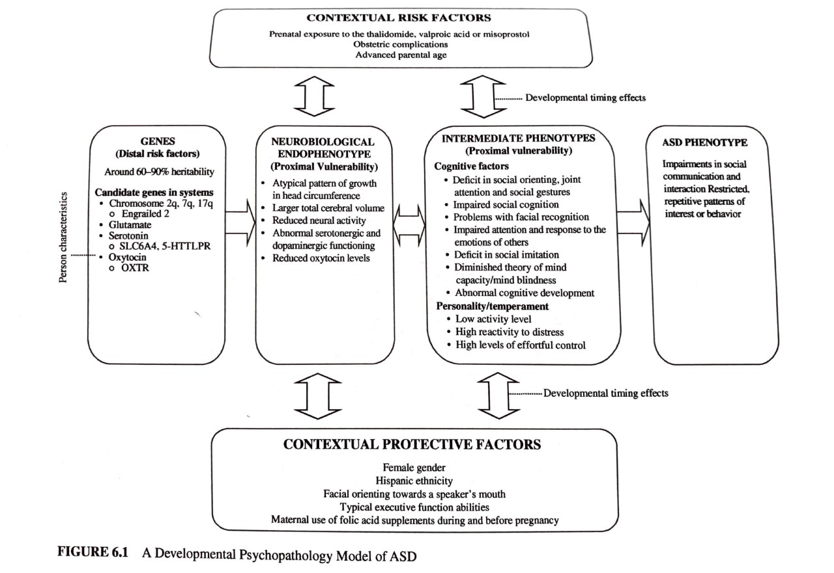

Attention-Deficit/Hyperactivity Disorder (ADHD)
- ADHD is a brain-based disorder characterized by problems with self-regulation of behavior, cognitive and motor skills, and inhibitory control
  - Maladaptive in that it is often comorbid with disruptive behavior that is often secondary to impulse control and hyperactivity
  - 2 primary dimensions: inattentive and them activity/impulsivity
  - Other criteria:
    - Age of onset (before 12)
    - pervasiveness (more than 1 setting)
    - Adaptive impairment (affecting functioning in school, work, and/or social settings)
- ADHD is not exclusionary, and may occur in relation to brain injury or prematurity

Diagnostic Criteria
A persistent pattern of inattention and/or hyperactivity-impulsivity that interferes with functioning or development, as characterized by (1) and/or (2):
1. Inattention: Six (or more) of the following symptoms have persisted for at least 6 months to a degree that is inconsistent with developmental level and that negatively impacts directly on social and academic/occupational activities:
Note: The symptoms are not solely a manifestation of oppositional behavior, defiance, hostility, or failure to understand tasks or instructions. For older adolescents and adults (age 17 and older), at least five symptoms are required.
a. Often fails to give close attention to details or makes careless mistakes in schoolwork, at work, or during other activities (e.g., overlooks or misses details, work is inaccurate).
b. Often has difficulty sustaining attention in tasks or play activities (e.g., has difficulty remaining focused during lectures, conversations, or lengthy reading).
c. Often does not seem to listen when spoken to directly (e.g., mind seems elsewhere, even in the absence of any obvious distraction).
d. Often does not follow through on instructions and fails to finish schoolwork, chores, or duties in the workplace (e.g., starts tasks but quickly loses focus and is easily sidetracked).
e. Often has difficulty organizing tasks and activities (e.g., difficulty managing sequential tasks; difficulty keeping materials and belongings in order; messy, disorganized work; has poor time management; fails to meet deadlines).
f. Often avoids, dislikes, or is reluctant to engage in tasks that require sustained mental effort (e.g., schoolwork or homework; for older adolescents and adults, preparing reports, completing forms, reviewing lengthy papers).
g. Often loses things necessary for tasks or activities (e.g., school materials, pencils, books, tools, wallets, keys, paperwork, eyeglasses, mobile telephones).
h. Is often easily distracted by extraneous stimuli (for older adolescents and adults, may include unrelated thoughts).
i. Is often forgetful in daily activities (e.g., doing chores, running errands; for older adolescents and adults, returning calls, paying bills, keeping appointments).
2. Hyperactivity and impulsivity: Six (or more) of the following symptoms have persisted for at least 6 months to a degree that is inconsistent with developmental level and that negatively impacts directly on social and academic/occupational activities:
Note: The symptoms are not solely a manifestation of oppositional behavior, defiance, hostility, or a failure to understand tasks or instructions. For older adolescents and adults (age 17 and older), at least five symptoms are required.
a. Often fidgets with or taps hands or feet or squirms in seat.
b. Often leaves seat in situations when remaining seated is expected (e.g., leaves his or her place in the classroom, in the office or other workplace, or in other situations that require remaining in place).
c. Often runs about or climbs in situations where it is inappropriate. (Note: In adolescents or adults, may be limited to feeling restless.)
d. Often unable to play or engage in leisure activities quietly.
e. Is often “on the go,” acting as if “driven by a motor” (e.g., is unable to be or uncomfortable being still for extended time, as in restaurants, meetings; may be experienced by others as being restless or difficult to keep up with).
f. Often talks excessively.
g. Often blurts out an answer before a question has been completed (e.g., completes people’s sentences; cannot wait for turn in conversation).
h. Often has difficulty waiting his or her turn (e.g., while waiting in line).
i. Often interrupts or intrudes on others (e.g., butts into conversations, games, or activities; may start using other people’s things without asking or receiving permission; for adolescents and adults, may intrude into or take over what others are doing).
B. Several inattentive or hyperactive-impulsive symptoms were present prior to age 12 years.
C. Several inattentive or hyperactive-impulsive symptoms are present in two or more settings (e.g., at home, school, or work; with friends or relatives; in other activities).
D. There is clear evidence that the symptoms interfere with, or reduce the quality of, social, academic, or occupational functioning.
E. The symptoms do not occur exclusively during the course of schizophrenia or another psychotic disorder and are not better explained by another mental disorder (e.g., mood disorder, anxiety disorder, dissociative disorder, personality disorder, substance intoxication or withdrawal).
Specify whether:
314.01 (F90.2) Combined presentation: If both Criterion A1 (inattention) and Criterion A2 (hyperactivity-impulsivity) are met for the past 6 months.
314.00 (F90.0) Predominantly inattentive presentation: If Criterion A1 (inattention) is met but Criterion A2 (hyperactivity-impulsivity) is not met for the past 6 months.
314.01 (F90.1) Predominantly hyperactive/impulsive presentation: If Criterion A2 (hyperactivity-impulsivity) is met and Criterion A1 (inattention) is not met for the past 6 months.
Specify if:
In partial remission: When full criteria were previously met, fewer than the full criteria have been met for the past 6 months, and the symptoms still result in impairment in social, academic, or occupational functioning. Specify current severity:
Mild: Few, if any, symptoms in excess of those required to make the diagnosis are present, and symptoms result in no more than minor impairments in social or occupational functioning.
Moderate: Symptoms or functional impairment between “mild” and “severe” are present.
Severe: Many symptoms in excess of those required to make the diagnosis, or several symptoms that are particularly severe, are present, or the symptoms result in marked impairment in social or occupational functioning.

Holistic Perspectives
- Very important to consider ALTERNATIVE EXPLAINATIONS
  - Impulsivity and hyperactivity are normal in children
    - What is important is if it becomes maladaptive and persists!
      - Example: many adults will self-report ADHD due to trouble concentrating at times, but the question remains on whether this significantly impairs with functioning (everyone struggles to focus sometimes)

Assessment of ADHD:
  - Structed interview that assesses for 5 domains (2 primary dimensions of ADHD, age of onset, pervasiveness, evidence of impact on function/adaptation, behaviors not explained by another disorder)
  - Report from multiple people (parent, teacher, PCP, etc.).
    - Agreement between raters may be low, and if so, the clinician may need to pay close attention to environment or child rearing strategies
  - Neuropsychological assessment
    - Is not necessary
    - Children often perform differently in a structured clinical setting rather than in real life
    - May be useful if there is the potential of comorbid LD

Prevalence
  - Boys more likely to be diagnosed than girls (bias in assessment?)
  - Sex-difference tends to diminish by adulthood
    - Hyperactivity tends to recede, while impulsivity and inattention remain
  - Percentage of diagnosis: Black children > white children > Asian and Latinx Children
    - Bias in reporting (teachers more likely to evaluate Black boy’s behaviors as impulsive, disruptive, hyperactive)
      - White teachers report ADHD symptoms higher in Black boys than that child’s parents do
    - Low-SES increases risk
      - Interaction of environmental factors caused by low-SES and the development of ADHD

Development and Continuity
  - ADHD symptoms tend to improve with age.
    - Hyper-motor activity is kids is very different than restlessness/fidgeting in adults
    - Improvements in attention and impulsivity as one ages, but teens and adults still show deficits compared to those w/o the diagnosis
  - Academic and vocational outcomes tend to be poorer
  - Social functioning is poorer and tends to persist
  - Elevated risk for substance abuse
  - Higher risk for antisocial behaviors as one ages (thrill seeking)

Emotion Regulation
  - Core issue in many children with ADHD, trouble inhibiting negative emotional responses
    - Children with comorbid behavioral problems tend to display a more fearful and hostile temperament.

IQ
  - Not a prominent consideration (children with ADHD range from IDD to gifted)
    - However, on average, children with ADHD, score 9 points lower. Reflects comorbidity with LD and challenges with reasoning skills.
      - Other factors, such as motivation, effort, and persistence may also be reflected in these scores

Executive Functioning:
  - Many definitions of EF, but generally is referred to as cognitive control that describes the functions of the prefrontal cortex to regulate cognitive and affective behavior.
  - EF has top-down regulatory behavior that are essential to goal directed behavior
  - Often struggle with:
    - Working memory
    - Shifting attention
    - Response control/inhibitory control
    - Planning
    - Problem solving
    - Metacogntition (self-awareness of the self in action)
    - Challenges in attention are related Moreso to regulatory attention (related to top-down processing). Bottom-up attention is not as impacted.
    - Motor coordination: children with ADHD tend to appear more clumsy and have poor fine motor skills
      - This is a result of challenges with procedural learning
      - Attention is related to learning (observe others do things before we do it)

Contextual Factors

Protective factors:
  - Structure, warmth, and discipline at home and in classroom
  - Having a best friend
  - Parental monitoring
  - High parenting efficacy
  - Strong relationship between parents

Risk factors:
  - Parent with ADHD or other mental illness
  - Low parental efficacy
  - Parental discord/disagreement in parenting
  - Poverty
  - Peer rejection
  - Single-parent, lower parental education
  - Less conscientious parents (ADHD kids prone to accidents)
  - Exposure to violence (increases risk of disruptive, aggressive behaviors)

Gene-environment interactions
  - Genetics factors (ADHD in parents often emerges in the assessment of the child)
  - Parents with ADHD themselves struggle to provide a structures and organized environment
  - Low birthweight and exposure to environmental toxins

Developmental timing
  - ADHD is persistent, but changes in appearance due to developmental timing
    - Hyperactivity decreases with age
    - Young adults/teens high risk of unsafe behaviors, impulsivity, substance misuse
    - Social challenges remain constant
    - Brain development may catch up some by adulthood
      - Treatment should include prevention of secondary effects (social aspects and achievement in school)

Intervention

Stimulations
  - Have an energizing effect on the nervous system that increases inhibitory control, which has a secondary effect on hyperactivity
  - Increases alertness, ability to focus, and sustain attention on task for longer periods of time
  - Methylphenidate (Ritalin), and dextroamphetamine (Adderall)
  - One or both effective in 80% of kids
  - A positive response to meds is not a diagnostic marker of ADHD (work on people w/o ADHD)
  - Side effects: insomnia, lack of appetite, lethargy. Often go away over time.

Therapy
  - Parent training/behavior management training
    - One of the most effective, particularly with young children
  - Goal directed counseling in teens
  - Social skills
  - School-based

Schizophrenia
  - Positive symptoms (delusions, hallucinations)
  - Negative symptoms (things present in most, but absent in those with schizophrenia), reduced facial expression, eye contact, speech intonation, and motivation, anhedonia, asociality
  - And/or disorganized speech and behavior
- Usually onsets in early 20s, sometimes teens. Rarely in childhood

Diagnostic Criteria

Two (or more) of the following, each present for a significant portion of time during a 1-month period (or less if successfully treated). At least one of these must be (1), (2), or (3):
1. Delusions.
2. Hallucinations.
3. Disorganized speech (e.g., frequent derailment or incoherence).
4. Grossly disorganized or catatonic behavior.
5. Negative symptoms (i.e., diminished emotional expression or avolition).
B. For a significant portion of the time since the onset of the disturbance, level of functioning in one or more major areas, such as work, interpersonal relations, or self-care, is markedly below the level achieved prior to the onset (or when the onset is in childhood or adolescence, there is failure to achieve expected level of interpersonal, academic, or occupational functioning).
C. Continuous signs of the disturbance persist for at least 6 months. This 6-month period must include at least 1 month of symptoms (or less if successfully treated) that meet Criterion A (i.e., active-phase symptoms) and may include periods of prodromal or residual symptoms. During these prodromal or residual periods, the signs of the disturbance may be manifested by only negative symptoms or by two or more symptoms listed in Criterion A present in an attenuated form (e.g., odd beliefs, unusual perceptual experiences).
D. Schizoaffective disorder and depressive or bipolar disorder with psychotic features have been ruled out because either 1) no major depressive or manic episodes have occurred concurrently with the active-phase symptoms, or 2) if mood episodes have occurred during active-phase symptoms, they have been present for a minority of the total duration of the active and residual periods of the illness.
E. The disturbance is not attributable to the physiological effects of a substance (e.g., a drug of abuse, a medication) or another medical condition.
F. If there is a history of autism spectrum disorder or a communication disorder of childhood onset, the additional diagnosis of schizophrenia is made only if prominent delusions or hallucinations, in addition to the other required symptoms of schizophrenia, are also present for at least 1 month (or less if successfully treated).
Specify if:
The following course specifiers are only to be used after a 1-year duration of the disorder and if they are not in contradiction to the diagnostic course criteria.
First episode, currently in acute episode: First manifestation of the disorder meeting the defining diagnostic symptom and time criteria. An acute episode is a time period in which the symptom criteria are fulfilled.
First episode, currently in partial remission: Partial remission is a period of time during which an improvement after a previous episode is maintained and in which the defining criteria of the disorder are only partially fulfilled.
First episode, currently in full remission: Full remission is a period of time after a previous episode during which no disorder-specific symptoms are present. Multiple episodes, currently in acute episode: Multiple episodes may be determined after a minimum of two episodes (i.e., after a first episode, a remission and a minimum of one relapse).
Multiple episodes, currently in partial remission
Multiple episodes, currently in full remission
Continuous: Symptoms fulfilling the diagnostic symptom criteria of the disorder are remaining for the majority of the illness course, with subthreshold symptom periods being very brief relative to the overall course.
Unspecified
Specify if:
With catatonia
Specify current severity:
Severity is rated by a quantitative assessment of the primary symptoms of psychosis, including delusions, hallucinations, disorganized speech, abnormal psychomotor behavior, and negative symptoms. Each of these symptoms may be rated for its current severity (most severe in the last 7 days) on a 5-point scale ranging from 0 (not present) to 4 (present and severe). (See Clinician-Rated Dimensions of Psychosis Symptom Severity in the chapter “Assessment Measures.”)
Note: Diagnosis of schizophrenia can be made without using this severity specifier.

Prevalence
- Occurs more in men than women (ratio 4:1)
- Typically emerges in adolescence or early childhood. Although, there are very rare cases in which psychosis emerges before the age of 12
- Controversy exists around racial prevalence of the disorder
  - Some statistics indicate that schizophrenia is more common in Black patients
    - Cultural isolation, discrimination, intersection with SES, and chronic stress related to system racism
      - At the same time, a bias is well documented that Black patients are more likely to be diagnosed with schizophrenia, while a White patient is more likely to be diagnosed with a mood disorder for similar a same presentation.

Developmental Continuities
- Schizophrenia is persistent – remission rates are low
- Homotypic – 80% of youth with schizophrenia continue to meet criteria as an adult
- Premorbid phase: early symptoms emerge, before diagnostic criteria is met (see following section)
- Prodromal schizophrenia is the earliest stage of schizophrenia. Not all people with schizophrenia experience this phase. Hallmark symptoms of the prodromal stage include nervousness, anxiety, depression, difficulty concentrating, excessive worrying, and more.
- Acute phase: full diagnostic criteria met. One acute phase is met, a person is unlikely to ever experience full remission. However, waxing and waning of positive symptoms typically occurs
- Residual Phase: more negative symptoms than positive. Positive symptoms tend to wax and wane. Tend to decrease over lifetime, and negative symptoms tend to not go away entirely with medication management
- Discussed in terms of episodes: when someone is experiencing more + symptoms

Premorbid Developmental Anomalies (Early Warning Signs)
- Delays in early language production, motor control development that emerge in infancy and continue into middle childhood
- Social difficulties (some parents may report autism-like traits)
- Cognitive impairments (IQ, school performance)
- These deficits may continue and worsen as schizophrenia develops, but it is not as simple as these factors worsening until schizophrenia criteria met – too simplistic considering the spectrum of experiences

Treatment
- Antipsychotic medications
  - Although the rarity of early childhood schizophrenia has led to a lack of research on the topic, antipsychotic medications have been found to be safe for children (used in clinical settings for ASD and behavioral problems)
- Cognitive Remediation Therapy
  - Goal-based, client’s problems are translated into achievable positively framed goals. Often includes the family.

Neurological Bases/Theories of Schizophrenia

Structural Anomalies
- Generally, have less gray matter in brain
- Reduced hippocampal volume
- Increased ventricular volume
  - Brain differences are not just a cause of schizophrenia but are also present before onet

Dopamine Hypothesis
- Overactive mesolimbic (reward pathway) dopaminergic neurons (produce dopamine) produce positive symptoms, while underactive mesocortical (pathway that has extensice connections within the frontal lobes and is involved in motivation, emotion, Exec. Functioning) dopaminergic neurons produce negative symptoms

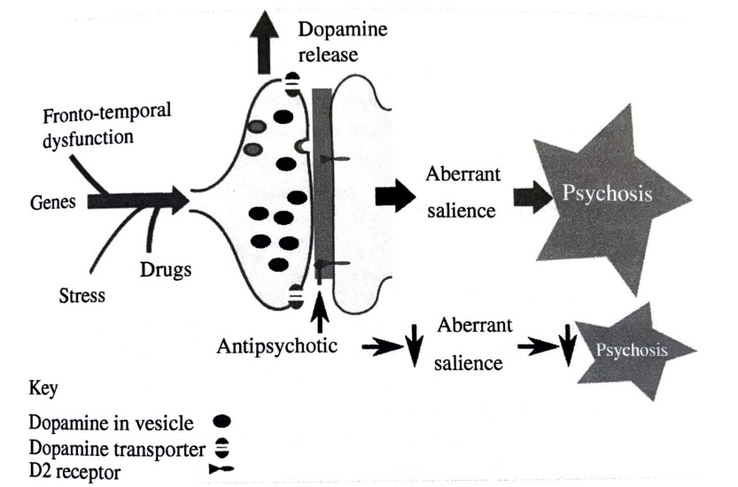

Glutamate Hypothesis
- Reduced function of glutamate receptors is responsible for impaired control of dopaminergic system

Developmental Model of Schizophrenia
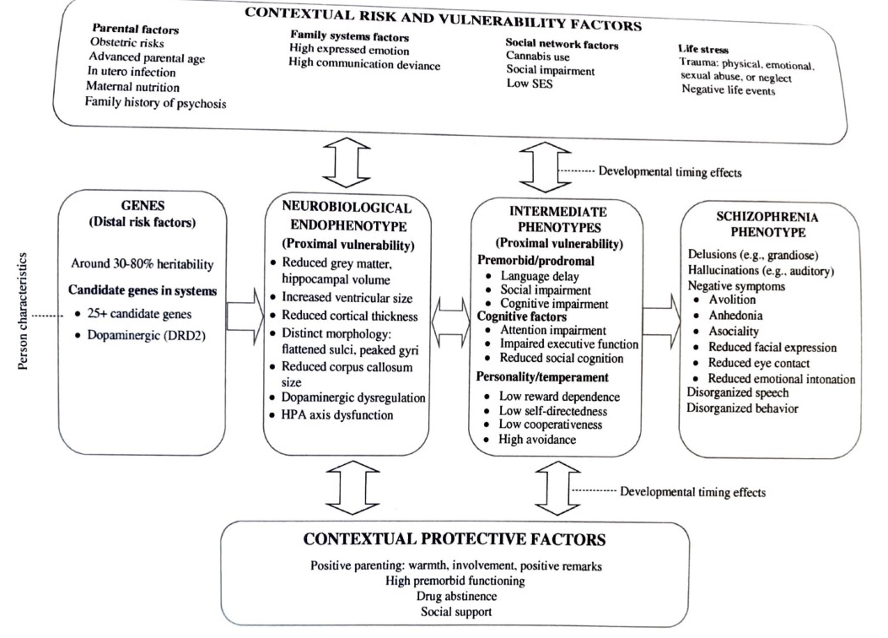

Eating Disorders

Anorexia Nervosa
Diagnostic Criteria
A. Restriction of energy intake relative to requirements, leading to a significantly low body weight in the context of age, sex, developmental trajectory, and physical health. Significantly low weight is defined as a weight that is less than minimally normal or, for children and adolescents, less than that minimally expected.
B. Intense fear of gaining weight or of becoming fat, or persistent behavior that interferes with weight gain, even though at a significantly low weight.
C. Disturbance in the way in which one’s body weight or shape is experienced, undue influence of body weight or shape on self-evaluation, or persistent lack of recognition of the seriousness of the current low body weight.
Specify whether:
Restricting type: During the last 3 months, the individual has not engaged in recurrent episodes of binge eating or purging behavior (i.e., self-induced vomiting or the misuse of laxatives, diuretics, or enemas). This subtype describes presentations in which weight loss is accomplished primarily through dieting, fasting, and/or excessive exercise.
Binge-eating/purging type: During the last 3 months, the individual has engaged in recurrent episodes of binge eating or purging behavior (i.e., self-induced vomiting or the misuse of laxatives, diuretics, or enemas).
Specify if:
In partial remission: After full criteria for anorexia nervosa were previously met, Criterion A (low body weight) has not been met for a sustained period, but either Criterion B (intense fear of gaining weight or becoming fat or behavior that interferes with weight gain) or Criterion C (disturbances in self-perception of weight and shape) is still met.
In full remission: After full criteria for anorexia nervosa were previously met, none of the criteria have been met for a sustained period of time.
Specify current severity: The minimum level of severity is based, for adults, on current body mass index (BMI) (see below) or, for children and adolescents, on BMI percentile. The ranges below are derived from World Health Organization categories for thinness in adults; for children and adolescents, corresponding BMI percentiles should be used. The level of severity may be increased to reflect clinical symptoms, the degree of functional disability, and the need for supervision.
Mild: BMI ≥ 17 kg/m2
Moderate: BMI 16–16.99 kg/m2
Severe: BMI 15–15.99 kg/m2
Extreme: BMI < 15 kg/m2

Bulimia Nervosa
Diagnostic Criteria 307.51 (F50.2)
A. Recurrent episodes of binge eating. An episode of binge eating is characterized by both of the following:
1. Eating, in a discrete period of time (e.g., within any 2-hour period), an amount of food that is definitely larger than what most individuals would eat in a similar period of time under similar circumstances.
2. A sense of lack of control over eating during the episode (e.g., a feeling that one cannot stop eating or control what or how much one is eating).
B. Recurrent inappropriate compensatory behaviors in order to prevent weight gain, such as self-induced vomiting; misuse of laxatives, diuretics, or other medications; fasting; or excessive exercise.
C. The binge eating and inappropriate compensatory behaviors both occur, on average, at least once a week for 3 months.
D. Self-evaluation is unduly influenced by body shape and weight.
E. The disturbance does not occur exclusively during episodes of anorexia nervosa.
Specify if:
In partial remission: After full criteria for bulimia nervosa were previously met, some, but not all, of the criteria have been met for a sustained period of time.
In full remission: After full criteria for bulimia nervosa were previously met, none of the criteria have been met for a sustained period of time.
Specify current severity: The minimum level of severity is based on the frequency of inappropriate compensatory behaviors (see below). The level of severity may be increased to reflect other symptoms and the degree of functional disability.
Mild: An average of 1–3 episodes of inappropriate compensatory behaviors per week.
Moderate: An average of 4–7 episodes of inappropriate compensatory behaviors per week.
Severe: An average of 8–13 episodes of inappropriate compensatory behaviors per week. Extreme: An average of 14 or more episodes of inappropriate compensatory behaviors per week.

Binge Eating Disorder
Diagnostic Criteria 307.51 (F50.8)
A. Recurrent episodes of binge eating. An episode of binge eating is characterized by both of the following:
1. Eating, in a discrete period of time (e.g., within any 2-hour period), an amount of food that is definitely larger than what most people would eat in a similar period of time under similar circumstances.
2. A sense of lack of control over eating during the episode (e.g., a feeling that one cannot stop eating or control what or how much one is eating).
B. The binge-eating episodes are associated with three (or more) of the following:
1. Eating much more rapidly than normal.
2. Eating until feeling uncomfortably full.
3. Eating large amounts of food when not feeling physically hungry.
4. Eating alone because of feeling embarrassed by how much one is eating.
5. Feeling disgusted with oneself, depressed, or very guilty afterward.
C. Marked distress regarding binge eating is present.
D. The binge eating occurs, on average, at least once a week for 3 months.
E. The binge eating is not associated with the recurrent use of inappropriate compensatory behavior as in bulimia nervosa and does not occur exclusively during the course of bulimia nervosa or anorexia nervosa.
Specify if:
In partial remission: After full criteria for binge-eating disorder were previously met, binge eating occurs at an average frequency of less than one episode per week for a sustained period of time.
In full remission: After full criteria for binge-eating disorder were previously met, none of the criteria have been met for a sustained period of time.
Specify current severity: The minimum level of severity is based on the frequency of episodes of binge eating (see below). The level of severity may be increased to reflect other symptoms and the degree of functional disability.
Mild: 1–3 binge-eating episodes per week.
Moderate: 4–7 binge-eating episodes per week.
Severe: 8–13 binge-eating episodes per week. Extreme: 14 or more binge-eating episodes per week.

Medical complications
- Food restriction causes a starvation/semi-starvation state:
  - Low heart rate, abnormal heart rhythms, low BP
  - Amenorrhea (loss of 3 consecutive menstrual cycles)
  - Loss of bone density, osteoporosis, bone fracture risk
  - Stunted growth,
  - changes in metabolic rate,
  - delayed gastric emptying leading to early fullness, bloating, and/or consticpation
  - dry skin, orange tint to skin
  - lanugo (downy hair on body)
- Purging:
  - Electrolyte imbalances leading to irregular heartbeat
  - Gastrointestinal complications from inappropriate laxative use
  - Irregular menstrual cycles and troubles with reproductive system
  - Tooth enamel erosion
  - Scars, calluses on knuckles
- Bing eating:
  - Enlargement of GI system which may perforate body tissue and infection
  - Obesity

Prevalence
- Female to male in 3-4:1 ratio
- Gay and bisexual men have more similar numbers to women
- More prevalent in teens than children
- Historically, viewed as a White, upper-SES disorder. Current statistics are controversial, and research needs to continue investigating in POC.
  - ED symptoms are often under-assessed in Black clients

Cognitive Factors
- Though distortions (particularly about self-image)
  - One’s self-image/perception of self is typically drastically distorted (thinking that oneself is much larger than they are)
- Perfectionism
- Need for control
- Ego-syntonic (symptoms are considered by the individual to be apart of their broader sense of self)
  - In other words, many people with ED (particularly Anorexia) do not want to change that they have an ED (it’s a rewarding cycle) and thus makes treatment difficult. Symptoms often create a sense of safety, power control and value
  - Binging symptoms are more ego-dystonic (inconsistent with the sense of self)
- Concern for weight any body image (as well as parental concern for their child’s weight and body image)

Developmental Model of Eating Disorders
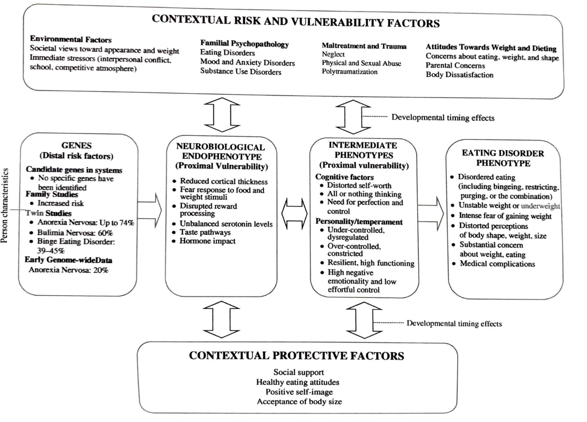

Substance-Use Disorder
- In the DSM-5, diagnoses exist for 10 different substance classes. Generally, consist of a problematic pattern that has resulted in clinically significant impairment or distress, over a long period of time, and evidence by at least 2/11 symptoms.
- Symptoms can be classified into the following categories
  - Impaired control
  - Social impairment
  - Risky use of substance
  - Pharmacological criteria (tolerance/withdrawal)

Alcohol Use Disorder
Diagnostic Criteria
A. A problematic pattern of alcohol use leading to clinically significant impairment or distress, as manifested by at least two of the following, occurring within a 12-month period:
1. Alcohol is often taken in larger amounts or over a longer period than was intended.
2. There is a persistent desire or unsuccessful efforts to cut down or control alcohol use.
3. A great deal of time is spent in activities necessary to obtain alcohol, use alcohol, or recover from its effects.
4. Craving, or a strong desire or urge to use alcohol.
5. Recurrent alcohol use resulting in a failure to fulfill major role obligations at work, school, or home.
6. Continued alcohol use despite having persistent or recurrent social or interpersonal problems caused or exacerbated by the effects of alcohol.
7. Important social, occupational, or recreational activities are given up or reduced because of alcohol use.
8. Recurrent alcohol use in situations in which it is physically hazardous.
9. Alcohol use is continued despite knowledge of having a persistent or recurrent physical or psychological problem that is likely to have been caused or exacerbated by alcohol.
10. Tolerance, as defined by either of the following:
a. A need for markedly increased amounts of alcohol to achieve intoxication or desired effect.
b. A markedly diminished effect with continued use of the same amount of alcohol.
11. Withdrawal, as manifested by either of the following:
a. The characteristic withdrawal syndrome for alcohol (refer to Criteria A and B of the criteria set for alcohol withdrawal).
b. Alcohol (or a closely related substance, such as a benzodiazepine) is taken to relieve or avoid withdrawal symptoms.
Specify if:
In early remission: After full criteria for alcohol use disorder were previously met, none of the criteria for alcohol use disorder have been met for at least 3 months but for less than 12 months (with the exception that Criterion A4, “Craving, or a strong desire or urge to use alcohol,” may be met).
In sustained remission: After full criteria for alcohol use disorder were previously met, none of the criteria for alcohol use disorder have been met at any time during a period of 12 months or longer (with the exception that Criterion A4, “Craving, or a strong desire or urge to use alcohol,” may be present).
Specify if:
In a controlled environment: This additional specifier is used if the individual is in an environment where access to alcohol is restricted.
Specify current severity:
305.20 (F12.10) Mild: Presence of 2–3 symptoms.
304.30 (F12.20) Moderate: Presence of 4–5 symptoms.
304.30 (F12.20) Severe: Presence of 6 or more symptoms.

Cannabis Use Disorder
Diagnostic Criteria
A. A problematic pattern of cannabis use leading to clinically significant impairment or distress, as manifested by at least two of the following, occurring within a 12-month period:
1. Cannabis is often taken in larger amounts or over a longer period than was intended.
2. There is a persistent desire or unsuccessful efforts to cut down or control cannabis use.
3. A great deal of time is spent in activities necessary to obtain cannabis, use cannabis, or recover from its effects.
4. Craving, or a strong desire or urge to use cannabis.
5. Recurrent cannabis use resulting in a failure to fulfill major role obligations at work, school, or home.
6. Continued cannabis use despite having persistent or recurrent social or interpersonal problems caused or exacerbated by the effects of cannabis.
7. Important social, occupational, or recreational activities are given up or reduced because of cannabis use.
8. Recurrent cannabis use in situations in which it is physically hazardous.
9. Cannabis use is continued despite knowledge of having a persistent or recurrent physical or psychological problem that is likely to have been caused or exacerbated by cannabis.
10. Tolerance, as defined by either of the following:
a. A need for markedly increased amounts of cannabis to achieve intoxication or desired effect.
b. Markedly diminished effect with continued use of the same amount of cannabis.
11. Withdrawal, as manifested by either of the following:
a. The characteristic withdrawal syndrome for cannabis (refer to Criteria A and B of the criteria set for cannabis withdrawal, pp. 517–518).
b. Cannabis (or a closely related substance) is taken to relieve or avoid withdrawal symptoms.
Specify if:
In early remission: After full criteria for cannabis use disorder were previously met, none of the criteria for cannabis use disorder have been met for at least 3 months but for less than 12 months (with the exception that Criterion A4, “Craving, or a strong desire or urge to use cannabis,” may be met).
In sustained remission: After full criteria for cannabis use disorder were previously met, none of the criteria for cannabis use disorder have been met at any time during a period of 12 months or longer (with the exception that Criterion A4, “Craving, or a strong desire or urge to use cannabis,” may be present).
Specify if:
In a controlled environment: This additional specifier is used if the individual is in an environment where access to cannabis is restricted.
Specify current severity:
305.20 (F12.10) Mild: Presence of 2–3 symptoms.
304.30 (F12.20) Moderate: Presence of 4–5 symptoms.
304.30 (F12.20) Severe: Presence of 6 or more symptoms.

Pathways to Substance Use Disorder

Externalizing Pathway
  - Related to executive functioning (planning, initiation, and regulation of goal directed behavior)
    - Consists of reasoning, foresight, attention, judgement, and self-monitoring, and motor control
    - Low/dysregulation EF has been related to substance misuse
  - Aggressive behavior and difficult temperaments linked to low exec functioning
    - Neurobehavioral disinhibition
    - Heightened sensation seeking is a risk factor
    - Aggression and delinquency often interact with family environments and increase risk of SUD
  - Some people may have a predisposition to a more sensitive dopamine reward system that increases risk of substance abuse

Internalizing pathway
  - Use substances to cope with emotional dysregulation
    - Emotional dysregulation in childhood and adolescence is associated with SUD
    - Self-medicated hypothesis – use substances to cope
    - Negative urgency – acting impulsively when experiencing an undesired emotion
    - Low-self-esteem, poor body image, lack of future planning, and self-blame increase risk

Repeated use pathway
  - substances change brain functioning
  - When a drug is removed after neurons have been accustomed to the frequent exposure and increased dopamine, the brain is then deprived of neurotransmitters (dopamine)
  - Underdeveloped Prefrontal cortex in adolescence is more susceptible to damage from substance abuse
  - Repeated drug use alters structure of mesolimbic pathway (reward system) and decreased prefrontal cortex’s executive functioning, thus leading to poor impulse control and low attention for non-drug stimuli
    - In other words, the more a teen uses drugs the harder it will be for them to direct their attention to other things

Risk factors:
  - Family conflict/ disruptions in family system, parent-child conflict, poor family management/ parental monitoring
  - Associating with deviant peers, sibling, and peer substance use. This can be exacerbated by poor relations with parents and low parental monitoring
  - Low attachment to school, and high classmate substance use
    - Counterintuitively, high rates of Substance use are found among teens with good grades, social motivation to attend school, and affiliation with other high achieving students
    - Low achievement is only a risk factor in the context of other risk factors
  - Exposure to neighborhood violence
  - Neighborhood advantage (white, middle to High-SES use more drugs)
  - Normalization of use by family/neighborhood culture is a risk factor

Developmental timing
  - Generally, adolescence is a sensitive time for the onset of SUD due to cognitive risk factors
    - Current stage of brain development (mesolimbic pathway/reward system) is more sensitive to alterations made by substances
    - Amygdala’s development is advanced compared to PFC – leads to impulsive, risky, socially-influenced decisions.
  - More susceptible to peer influence (see section on peer relations)

Developmental Model of Substance Use Disorder
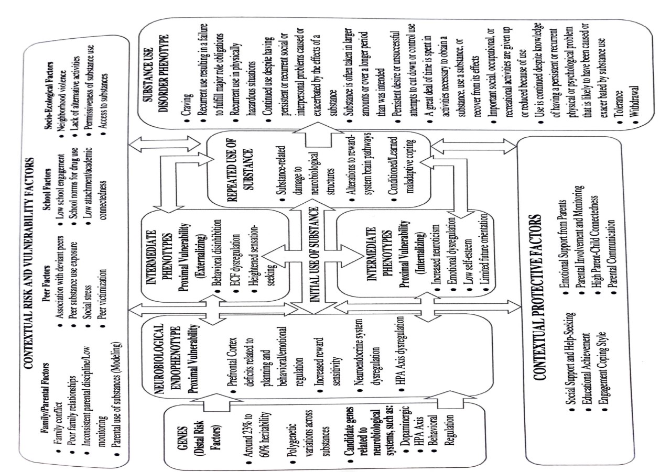

Conduct-Related Disorders

Oppositional-Defiant Disorder
Diagnostic Criteria
A. A pattern of angry/irritable mood, argumentative/defiant behavior, or vindictiveness lasting at least 6 months as evidenced by at least four symptoms from any of the following categories, and exhibited during interaction with at least one individual who is not a sibling.
Angry/Irritable Mood:
1. Often loses temper.
2. Is often touchy or easily annoyed.
3. Is often angry and resentful.
Argumentative/Defiant Behavior
4. Often argues with authority figures or, for children and adolescents, with adults.
5. Often actively defies or refuses to comply with requests from authority figures or with rules.
6. Often deliberately annoys others.
7. Often blames others for his or her mistakes or misbehavior.
Vindictiveness
8. Has been spiteful or vindictive at least twice within the past 6 months.
Note: The persistence and frequency of these behaviors should be used to distinguish a behavior that is within normal limits from a behavior that is symptomatic. For children younger than 5 years, the behavior should occur on most days for a period of at least 6 months unless otherwise noted (Criterion A8). For individuals 5 years or older, the behavior should occur at least once per week for at least 6 months, unless otherwise noted (Criterion A8). While these frequency criteria provide guidance on a minimal level of frequency to define symptoms, other factors should also be considered, such as whether the frequency and intensity of the behaviors are outside a range that is normative for the individual’s developmental level, gender, and culture.
B. The disturbance in behavior is associated with distress in the individual or others in his or her immediate social context (e.g., family, peer group, work colleagues), or it impacts negatively on social, educational, occupational, or other important areas of functioning.
C. The behaviors do not occur exclusively during the course of a psychotic, substance use, depressive, or bipolar disorder. Also, the criteria are not met for disruptive mood dysregulation disorder.
Specify current severity:
Mild: Symptoms are confined to only one setting (e.g., at home, at school, at work, with peers).
Moderate: Some symptoms are present in at least two settings.
Severe: Some symptoms are present in three or more settings

Conduct Disorder
Diagnostic Criteria
A. A repetitive and persistent pattern of behavior in which the basic rights of others or major age-appropriate societal norms or rules are violated, as manifested by the presence of at least three of the following 15 criteria in the past 12 months from any of the categories below, with at least one criterion present in the past 6 months:
Aggression to People and Animals
1. Often bullies, threatens, or intimidates others.
2. Often initiates physical fights.
3. Has used a weapon that can cause serious physical harm to others (e.g., a bat, brick, broken bottle, knife, gun
4. Has been physically cruel to people.
5. Has been physically cruel to animals.
6. Has stolen while confronting a victim (e.g., mugging, purse snatching, extortion, armed robbery).
7. Has forced someone into sexual activity.
Destruction of Property
8. Has deliberately engaged in fire setting with the intention of causing serious damage.
9. Has deliberately destroyed others’ property (other than by fire setting).
Deceitfulness or Theft
10. Has broken into someone else’s house, building, or car.
11. Often lies to obtain goods or favors or to avoid obligations (i.e., “cons” others).
12. Has stolen items of nontrivial value without confronting a victim (e.g., shoplifting, but without breaking and entering; forgery).
Serious Violations of Rules
13. Often stays out at night despite parental prohibitions, beginning before age 13 years.
14. Has run away from home overnight at least twice while living in the parental or parental surrogate home, or once without returning for a lengthy period.
15. Is often truant from school, beginning before age 13 years.
B. The disturbance in behavior causes clinically significant impairment in social, academic, or occupational functioning.
C. If the individual is age 18 years or older, criteria are not met for antisocial personality disorder.
Specify whether:
Childhood-onset type: Individuals show at least one symptom characteristic of conduct disorder prior to age 10 years.
Adolescent-onset type: Individuals show no symptom characteristic of conduct disorder prior to age 10 years.
Unspecified onset: Criteria for a diagnosis of conduct disorder are met, but there is not enough information available to determine whether the onset of the first symptom was before or after age 10 years.
Specify if:
With limited prosocial emotions: To qualify for this specifier, an individual must have displayed at least two of the following characteristics persistently over at least 12 months and in multiple relationships and settings. These characteristics reflect the individual’s typical pattern of interpersonal and emotional functioning over this period and not just occasional occurrences in some situations. Thus, to assess the criteria for the specifier, multiple information sources are necessary. In addition to the individual’s self-report, it is necessary to consider reports by others who have known the individual for extended periods of time (e.g., parents, teachers, co-workers, extended family members, peers).
Lack of remorse or guilt: Does not feel bad or guilty when he or she does something wrong (exclude remorse when expressed only when caught and/or facing punishment). The individual shows a general lack of concern about the negative consequences of his or her actions. For example, the individual is not remorseful after hurting someone or does not care about the consequences of breaking rules.
Callous—lack of empathy: Disregards and is unconcerned about the feelings of others. The individual is described as cold and uncaring. The person appears more concerned about the effects of his or her actions on himself or herself, rather than their effects on others, even when they result in substantial harm to others.
Unconcerned about performance: Does not show concern about poor/problematic performance at school, at work, or in other important activities. The individual does not put forth the effort necessary to perform well, even when expectations are clear, and typically blames others for his or her poor performance.
Shallow or deficient affect: Does not express feelings or show emotions to others, except in ways that seem shallow, insincere, or superficial (e.g., actions contradict the emotion displayed; can turn emotions “on” or “off” quickly) or when emotional expressions are used for gain (e.g., emotions displayed to manipulate or intimidate others).
Specify current severity:
Mild: Few if any conduct problems in excess of those required to make the diagnosis are present, and conduct problems cause relatively minor harm to others (e.g., lying, truancy, staying out after dark without permission, other rule breaking).
Moderate: The number of conduct problems and the effect on others are intermediate between those specified in “mild” and those in “severe” (e.g., stealing without confronting a victim, vandalism).
Severe: Many conduct problems in excess of those required to make the diagnosis are present, or conduct problems cause considerable harm to others (e.g., forced sex, physical cruelty, use of a weapon, stealing while confronting a victim, breaking and entering).

ODD vs. CD
- Generally, ODD is related to poor emotion regulation skills that manifest as outburst, defiance, aggression. CD emerges as behaviors that violate societal rules or the rights of others
- While the symptoms of ODD and CD overlap, CD is more extreme, often seen to develop from ODD that emerges in earlier childhood
- The behaviors of oppositional defiant disorder are typically of a less severe nature than those of individuals with conduct disorder and do not include aggression toward individuals or animals, destruction of property, or a pattern of theft or deceit. Furthermore, oppositional defiant disorder includes problems of emotional dysregulation (i.e., angry and irritable mood) that are not included in the definition of conduct disorder. When criteria are met for both oppositional defiant disorder and conduct disorder, both diagnoses can be given.

Antisocial Personality Disorder
Diagnostic Criteria 301.7 (F60.2)
A. A pervasive pattern of disregard for and violation of the rights of others, occurring since age 15 years, as indicated by three (or more) of the following:
1. Failure to conform to social norms with respect to lawful behaviors, as indicated by repeatedly performing acts that are grounds for arrest.
2. Deceitfulness, as indicated by repeated lying, use of aliases, or conning others for personal profit or pleasure.
3. Impulsivity or failure to plan ahead.
4. Irritability and aggressiveness, as indicated by repeated physical fights or assaults.
5. Reckless disregard for safety of self or others.
6. Consistent irresponsibility, as indicated by repeated failure to sustain consistent work behavior or honor financial obligations.
7. Lack of remorse, as indicated by being indifferent to or rationalizing having hurt, mistreated, or stolen from another.
B. The individual is at least age 18 years.
C. There is evidence of conduct disorder with onset before age 15 years.
D. The occurrence of antisocial behavior is not exclusively during the course of schizophrenia or bipolar disorder.

Intermitted Explosive Disorder
Diagnostic Criteria 312.34 (F63.81):
A. Recurrent behavioral outbursts representing a failure to control aggressive impulses as manifested by either of the following:
1. Verbal aggression (e.g., temper tantrums, tirades, verbal arguments or fights) or physical aggression toward property, animals, or other individuals, occurring twice weekly, on average, for a period of 3 months. The physical aggression does not result in damage or destruction of property and does not result in physical injury to animals or other individuals.
2. Three behavioral outbursts involving damage or destruction of property and/or physical assault involving physical injury against animals or other individuals occurring within a 12-month period.
B. The magnitude of aggressiveness expressed during the recurrent outbursts is grossly out of proportion to the provocation or to any precipitating psychosocial stressors.
C. The recurrent aggressive outbursts are not premeditated (i.e., they are impulsive and/ or anger-based) and are not committed to achieve some tangible objective (e.g., money, power, intimidation).
D. The recurrent aggressive outbursts cause either marked distress in the individual or impairment in occupational or interpersonal functioning, or are associated with financial or legal consequences.
E. Chronological age is at least 6 years (or equivalent developmental level).
F. The recurrent aggressive outbursts are not better explained by another mental disorder (e.g., major depressive disorder, bipolar disorder, disruptive mood dysregulation disorder, a psychotic disorder, antisocial personality disorder, borderline personality disorder) and are not attributable to another medical condition (e.g., head trauma, Alzheimer’s disease) or to the physiological effects of a substance (e.g., a drug of abuse, a medication). For children ages 6–18 years, aggressive behavior that occurs as part of an adjustment disorder should not be considered for this diagnosis.
Note: This diagnosis can be made in addition to the diagnosis of attention-deficit/hyperactivity disorder, conduct disorder, oppositional defiant disorder, or autism spectrum disorder when recurrent impulsive aggressive outbursts are in excess of those usually seen in these disorders and warrant independent clinical attention.

Callous and Unemotional Traits
There is a lot of heterogeneity among those with ODD and CD. One of the most important traits in CD is a callous and unemotional (CU) interpersonal style:
- Lack of remorse and guilt
- Callous lack of empathy
- Lack of concern about performance
- Shallow of deficient affect
- Tend to see dominance and aggression as appropriate ways to act In social situations, underestimate the likelihood of being punished, and are insensitive to punishment
High/Low CU affects the presentation of CD
- Low CU is typically more aggressive
  - Characterized by neuroticism and poor emotion regulation
  - Aggression tends to decrease into adolescence/adulthood
- High CU is typically “rule-breaking”
  - Greater impulsivity
  - Tends to increase into adolescence/adulthood

Prevalence
- Antisocial behavior tends to emerge in childhood or adolescents
  - Very rare for ODD/CD to onset in adulthood
  - The first symptoms of ODD tend to appear in preschool years
  - Highest prevalence of CD is in adolescents
  - Tends to be more common in males, especially in childhood onset
    - However, some evidence that this gap is narrowing
  - Males tend to display more physically aggressive symptoms
  - No major difference in prevalence related to race/ethnicity
  - Children from LOW-SES are 4x as likely to have ODD

Comorbidity
- 1/3 of boys with ADHD develop CD
- Strong association between ADHD and behavioral problems
  - May have similar genetic components
- Comorbid with depression, mood disorders, LD

Developmental Continuities
- Begins in early childhood and tends to become more stable in middle child-hood/ adolescents
- 60% of adults with ASPD were diagnosed with childhood-onset CD
- Majority of children with ODD do not develop CD (just more severe ones), but are at higher risk of developing anxiety of depressions
  - Although ODD can proceed CD, childhood onset type
  - The defiant, argumentative, and vindictive symptoms carry most of the risk for conduct disorder, whereas the angry-irritable mood symptoms carry most of the risk for emotional disorders.
- CD is more persistent than ODD
- Critical Period for the onset of CD is middle childhood à middle adolescence
  - CD emerging before puberty is likely to be severe and influenced by neuropsychological deficits
  - Aggressive/rule breaking CD had a stronger genetic basis
  - Rule breaking CD has a stronger environmental etiology

Temperament
- low self-control
- High in negative emotional reactivity
- Childhood onset conduct problems are more likely to be related to temperamental vulnerabilities than onset of CD
- How parents react to conduct problems affects the developmental trajectory

Risk factors

Cognitive
- Lower IQ and language skills in preschool

Environmental
- Harsh, inconsistent, neglectful parenting
- Child abuse
- Stability of family relationships
- Frequent changes of caregivers
- Parental hostility
- Parental psychopathology (Depression, SUD)
- Parental violence/conflict

Protective factors
- Stable and supportive home
- Genetics (no SUD, CD reported in family)

Developmental Model of Antisocial Behaviors
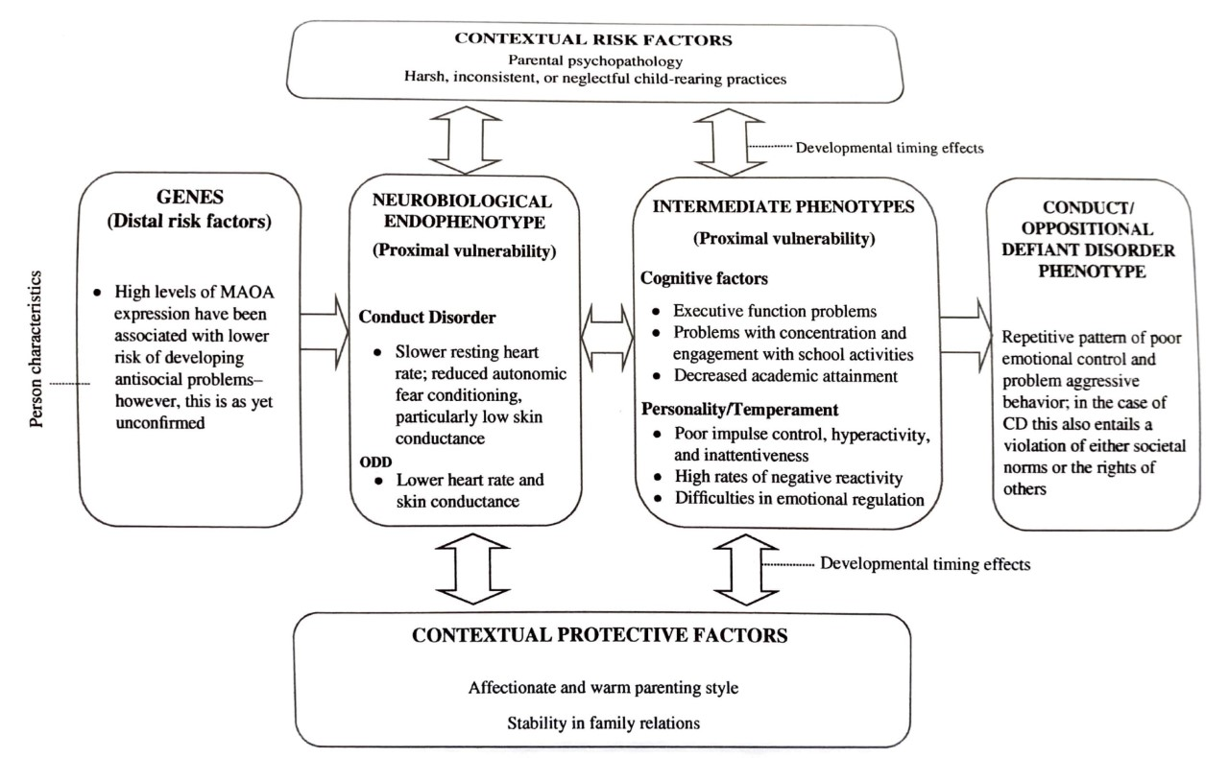

Borderline Personality Disorder
Personality Disorders are defined by pervasive and inflexible patterns of feeling and behavior that onset in adolescence or early adulthood that cause significant distress of impairment.
- Cluster A: includes paranoid, schizoid, and schizotypal personality disorders. Individuals with these disorders often appear odd or eccentric.
- Cluster B: includes antisocial, borderline, histrionic, and narcissistic personality disorders. Individuals with these disorders often appear dramatic, emotional, or erratic.
- Cluster C: includes avoidant, dependent, and obsessive-compulsive personality disorders. Individuals with these disorders often appear anxious or fearful.

Diagnostic Criteria
A pervasive pattern of instability of interpersonal relationships, self-image, and affects, and marked impulsivity, beginning by early adulthood and present in a variety of contexts, as indicated by five (or more) of the following:
1. Frantic efforts to avoid real or imagined abandonment. (Note: Do not include suicidal or self-mutilating behavior covered in Criterion 5.)
2. A pattern of unstable and intense interpersonal relationships characterized by alternating between extremes of idealization and devaluation.
3. Identity disturbance: markedly and persistently unstable self-image or sense of self.
4. Impulsivity in at least two areas that are potentially self-damaging (e.g., spending, sex, substance abuse, reckless driving, binge eating). (Note: Do not include suicidal or selfmutilating behavior covered in Criterion 5.)
5. Recurrent suicidal behavior, gestures, or threats, or self-mutilating behavior.
6. Affective instability due to a marked reactivity of mood (e.g., intense episodic dysphoria, irritability, or anxiety usually lasting a few hours and only rarely more than a few days).
7. Chronic feelings of emptiness.
8. Inappropriate, intense anger or difficulty controlling anger (e.g., frequent displays of temper, constant anger, recurrent physical fights).
9. Transient, stress-related paranoid ideation or severe dissociative symptoms.

Prevalence
- Occurs in 1-3% of general population
- Almost always comorbid with another diagnosis
- Often thought to be more common in women, but recent studies show that gap may be more narrow than we typically thought.

Developmental Continuities
- New challenges during adolescence increase vulnerability of onset
  - Interpersonal demands (friendships,romance)
  - Adolescence is a sensitive period of many developmental changes in the self and interpersonally take place – thus personality disorders do not occur before these developmental advances
- BPD has homotypic continuity (traits remain relatively stable into adulthood)
- However, issues with emotion regulation and impulsivity in early childhood show heterotypic continuity and may be a risk factor for BPD
- Acute, externalizing behaviors in BPD are more common in teens than adults, while internalizing symptoms increase with age
- Children who experience maltreatment early-on are at higher risk than children who experience abuse in later childhood

Risk factors

Neurological
- HPA-axis/sensitive stress response system (often trauma-related)
- Attachment (oxytocin receptor issues)
- Fronto-limbic abnormalities (emotion regulation system)
- Challenges with planning ahead and inhibit responses

Contextual
- Child abuse and neglect
- Parent psychopathology
- Insecure attachment as a child and adult (unresolved, fearful, anxious, preoccupied)
- Maladaptive parenting (low warmth, high hostility, harsh discipline)
- Peer victimization

Developmental Model of BPD
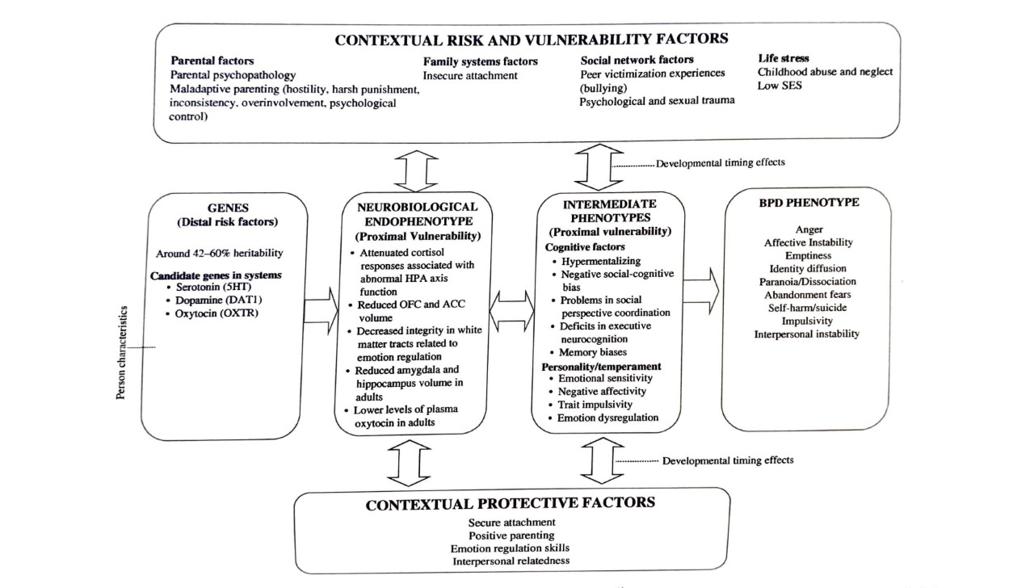

Part II. Diagnosis Nonspecific Contextual Factors

Self-Processes in Childhood
Theory of Self Awareness & Self-Concept in a Developmental Lens:
- I-Self: self-awareness, sense of agency, continuity, and coherence of self
- Me-Self: refection of oneself in the “psychological mirror” – one’s concept of self (perception of competence, appearance, social acceptability, self-esteem)

Very Early Childhood (2-4)
- Concrete cognitive representations of me-self – observable features (gender, toys they have, family members they have)
  - Young Child understand self as only separate, observable, and categorized features that may be physical (how they look), active (things they can do), social (family members), psychological (primary emotions).
  - Concepts are highly differentiated and isolated from each other. Disjointed.
    - Young child unable to integrate these features into a comprehensive understanding of self.
  - Transductive thinking – see connection between unrelated events
    - Can form rudimentary links between events (physical dimensions, behaviors, habitual activities), but cannot integrate single structures together- in part to limitations in working memory at this age.
- I-self:
  - Can now describe self, including internal states (awareness). Understanding control over one’s actions (agency). Understands self as invariant over-time despite slight changes such as change clothes or a haircut (continuity). Autobiographical memory plays an important role in continuity. Self-coherence is not met at this age, due to inability to integrate concepts of self
- Self-enhancement strategies: do not engage in as they do not understand other’s perspectives of them. Self-perceptions are already very inflated. Normative Narcissism: normal for child of this age to desire being center of attention

Early to Middle Childhood (5-7)
- Me-Self descriptions include competencies (I am good at school), physical competencies (I can climb the monkey bars), and social skills (I have a lot of friends).
  - Self-image is of total virtuosity (if you are good at things, you cannot be bad at things)
    - Black & white thinking persists at this age.
form rudimentary ability to integrate concepts that were once compartmentalized.
  - Form a representation of a set of related skills (I can jump, run and climb; I know my letters and numbers!)
    - Black & white thinking persists due to the emergence of rudimentary ability to relate representational sets to one another (identify opposites), but has trouble doing so meaningfully
      - Example: Because child understands self a good in many skills, and good is the opposite of bad, this cognitive construction precludes children at this age from being bad (total virtuosity)
      - Inability to understand that oneself can hold both positive and negative qualities at the same time
- I-self
  - Metacognitive awareness: more aware of how they are viewed by others, limited perspective taking ability, understanding that others are observing/evaluating them
  - Cultural-Self (awareness): autobiographical self-history, narratives of self, influenced by their cultural setting (values, institutions, environment)
- Self-enhancement strategies: normal overestimation of competencies form earlier stage carry over. 1. Unable to engage in social comparison for purpose of self-evaluation, temporal comparison (oneself is better than I used to be) is used to inflate sense of self, 3. Inability to differentiate ideal self from actual self, 4 lack of perspective taking, 5 inability to acknowledge that self has both positive and negative qualities.
  - However, child may lie to conceal doing something wrong. However, efforts are typically very transparent.

Middle-to-late Childhood (8-10)
- Me-Self: Can now describe self in generalizations (nice, smart, cool!)
  - Acknowledge that they can possess both positive and negative attributes
    - Can hold several emotions at once.
  - Integrate concepts to make generalizations (Smart because they are good at several subjects in school and enjoy reading).
  - Self-esteem emerges around age 8
    - Can form a concept of self-worth based on integration of evaluations from others across domains they view as important
  - Challenges at this age: (1) perceptions may be less than accurate as the child is unexperienced in connecting objective evidence into realistic self-perceptions (i.e. translating observable academic success into a perception of intelligence). (2) challenged understanding others’ perceptions
- I-Self: increased self-awareness and decreased egocentrism. Narratives of self & emerging self-efficacy display sense of self-agency and self-continuity. Child understands themselves as authors of their own narratives.
- Self-enhancement strategies: now that self-esteem has developed (able to understand other’s perceptions of themselves) may use 1. Downward social comparison, 2. better-than-average strategy, 3. Impression management (doing what peers think is cool), 4 discount importance of domains oneself is not good at.

Early adolescence (11-13)
- Me-self: new cognitive abilities allow for abstract descriptions of self (describe self as intelligent based on ideas that oneself is smart, curious, and hardworking.
  - Trait labels can now be appropriately integrated into higher-order generalizations
    - These abstract representations are highly compartmentalized (similar to early childhood)
    - Single-abstractions are over-differentiated, so young adolescent can only think about each abstraction as an isolated self-attribute.
      - When adolescent first develops ability to think abstractly, they lack ability to integrate many abstractions (all-or-nothing thinking at an abstract level). Think about self-attributes one at a time but not simultaneously (do not understand that they can be extroverted in some situations and introverted in others)
      - More abstract representations re further removed from concrete behavioral evidence / documentation at this age and may lead to inaccurate self-evaluations.
      - Compartmentalization = young adolescent is unaware of an and unconcerned about inconsistencies in behaviors across roles/relationships. Advantaged is that they are not yet distressed about perceived inconsistencies in self.
- I-Self: social awareness increases. Compartmentalization (unawareness of multiple selves across contexts) interferes with agency and self-coherence and self-continuity.
- Self-enhancement strategies: downward social comparison, deflect faults to external situations, beneffectance (self-protective strategy where one’s positive qualities are salient and negative ones are pushed to the periphery)

Middle adolescence (14-16)
- Me-self: aware that one is inconsistent across contexts, and this is often distressing to the adolescent due to improvements in I-self (now able to make comparisons between abstractions; called abstract mapping)
  - Conflict of the different me’s: Adolescent is not yet able to truly integrate conflicting self-representation in a manner that would resolve the perceived contradictions
      - Example: Thinking that oneself is acting “fake” In front of classmates, as one noticed that they are extraverted in that setting and introverted in others.
- I-Self: Self-awareness is very intense. Awareness shifts from role-to-role where oneself is identified quiet differently (coined: kaleidoscope self)
  - Makes it Challenging for middle adolescent to project a clear image of themselves into the future (self-continuity/self-coherence), and to make logical decisions (may feel like a never-ending swirl of choices).
Self-enhancement strategies are similar to those in previous stage

Late adolescence (17-19)
- Potentially contradictory characteristics are no longer viewed in opposition of one another
  - View self as flexible, dynamic
  - Higher-level abstract thinking allows for coordination of single abstractions
- I-self: personal beliefs, values become more internalized. Gives them a sense of direction, but over over idealistic. Have greater sense of agency, self-continuity, and self-coherence
- Self enhancement strategies now include endorsing false-opinions to gain approval

Roots of Consciousness
- Research suggests implicit consciousness may begin as early s 8 weeks after conception (awareness of sensory input)
- Fetuses in last trimester can learn habitually from sensory input& is transferable to after birth

Awareness at birth and in infancy
- Aware of sensations, but have minimal to no self-awareness
  - aware of motions, where pieces of space contrast, detach, move, meet, overlap, and vanish
  - Synesthesia is when you hear music, but you see shapes. Or you hear a word or a name and instantly see a color. Synesthesia is a fancy name for when you experience one of your senses through another
  - Implicit learning
  - Can link sensory experiences together (toddlers associate bright colors with high-pitch voice)
  - While infants are not yet self-aware, they do differentiate their sensory experience from other objects
  - Infants are active, and not just passive learners.
  - Active in processing invariant info over change. Trying to focus on sameness to establish safety
  - By 6 months baby has many expectations about the world
  - Object permanence 5 months
  - Infantile amnesia (lack explicit memories before age 2) – related to rapid brain development first years of life, and also that language development around age 2
  - Intersubjectivity being – communicate and reciprocate. Expect others to respond in a certain way (distressed if parent has blank face study).
      - Beyond mirroring, and actually engaging in reciprocal social exchange. Joint attention between 7-9 months
    - Intentional communication around 9 months
  - Self-awareness 21 months (mirror test)
  - Secondary emotions around 2-3 years
    - Pretend play

Peer Relations

Young Children
  - Cascade model involving transactions between temperament characteristics and response from environment that conjointly influence internalizing symptom trajectories.
    - Behavioral inhibition in first years of live may evoke overprotective parenting response that in turn exacerbates inhibition and withdrawal behavior

School aged Children
  - Challenged emergence in ability to develop reciprocating interest with peers
  - Peer status used as a measure to success in peer group
    - Acceptance/rejection appears to be stable across contexts and time
      - May serve as a marker for other difficulties
    - Aggressive children less likely to be accepted
      - Mutually reinforcing
    - Rejected children more likely to develop internalizing problems
      - Stress from peer rejection may have similar affects on HPA axis as other chronic stressors
      - Influence development of depression

Adolescence
  - Homophily- likely to engage in behaviors like peers
  - Selection effect: likely to choose friends like self
    - Perception of friend’s behaviors is more predictive of them engaging in it as well
    - Often influenced by high-status peers even if not their friend
      - More likely to engage in deviant behavior if endorsed by high status peer
  - Socialization of depressive symptoms likely to occur in friendship dyads – co-rumination
  - Socialization of alcohol likely to occur in groups
    - Behaviors are adopted through modeling, operant reinforcement (social reward, sanctions), observational learning, wanting to adhere to social norms.

Family Systems

Bowen Family Systems
- Emphasis on family boundaries, differentiation of self from family, detriangulation
  - Triangulation: a 2 person family system is vulnerable to emotional forces from within it and outside of it, according to Bowen
  - Thus, gravitates to including a 3rd party for stability.
    - Diffuses anxiety and prevents from any dyad in the triangle from becoming overheated
    - 3rd person is not inherently problematic, if all persons remain simultaneously connected and 3rd person remains emotionally detached from others’ conflict.
    - Triangulation/becoming symptomatic may be a method to bring members together when one has been left out.
    - Couples may project problems onto children
    - Family projection is predicted by marital fusion – when lack of differentiation between parents evokes anxiety, they may alleviate this by turning to the child.

Minuchin’s Structural Family Theory
- Emphasized boundaries around parental subsystem
  - When children become inappropriately involved in the interparental relationship, neither the family nor individuals can function appropriately
  - Rigid triangles – coalition is when the child forms an overly close relationship with a parent that excludes the other. This prevents the couple from achieving intimacy and carrying out responsibilities as parents. Triangulation is when a parent attempts to enlist the exclusive loyalty of the child. This places the child in a bind, where they are unable to achieve emotional closeness with both parents. Forming closeness with one parent alienates or angers the other. Detouring is parents projecting issues within their relationship onto the child (supporting is when parents unite around caregiving tasks, attacking is when the child is used as a scapegoat for problems)

Functional Family Perspective
  - Relational functions- “healthy strivings” – functions each member is trying to achieve
    - Conceptualized for each dyad within the family
  - Relational Hierarchy – relative balance of power in relationships
  - Relational Connection – balance between member’s need for connection vs autonomy
    - Dysfunction occurs when there is a mismatch between member’s relational functions that prevents needs from being met (EX: connection seeking father with a autonomy seeking child).
      - Encouraged maladaptive ways of getting need met

Holism & viewing family as a system
  - Spillover- conflict between parents spills over into parent-child relationship, such as by increasing negativity in parenting, decreasing parental emotional availability, or compromising child’s sense of security.
  - Compensation- issues between parents may led to compensatory closeness between a parent and child that imbalances the family system
  - Circularity- cause-and-effects in systems are not uni-directional, but influence each other reciprocally, mutually and bidirectionally
  - Homeostasis- why families seem to fall back into pathological tendencies and resists therapeutic change. Constancy and regularity is maintained in the face of every-changing stressors.

Boundaries
  - Enmeshment families in which members are highly overinvolved with and emotionally overreactive to each other.
    - poor boundaries and triangulation
    - increased risk of internalized disorders and attachment insecurity in children
  - Parentification is a form of boundary dissolution in which parents turn to children or nurturance, comradeship, or instrumental assistance
  - Adultification/role diffusion parent treats child not as a parent, but as an agemate. The parent may behave like a child, or promote the child to the status of a adult-peer
  - Spouceification is a rare boundary dissolution when a parent may treat a child more like an intimate partner. Parent is overly flirtatious and intimate with the child
  - Intrusiveness are parental behaviors that are intrusive and manipulative of the child’s thoughts, feelings, and attachment (guilt induction or withdrawal of love to manipulate behaviors)

Change Processes in Family Systems
  - 1- stress precipitates change by causing disequilibrium in the family system. This causes them to abandon less-effective strategies and develop more adaptive ways to meet the challenge
  - 2-realted to Erikson’s developmental stages theory, each stage gives rise to new challenges for families and requires adaptation. This includes 3 tasks:
    - Task 1 establishes family identity – establish boundaries
    - Task 2 establishes commitment to set boundaries, structure, values
    - Task 3 consolidates family identity and generativity for future
      - Difficulties with these relate to developmental status of people in family
  - Epigenetic relational system- 5 processes unfold in family systems 1- attachment and bonding, 2 communication and sharing meaning, 3 joint problem solving and engaging in tasks together, 4 mutuality which involves reevaluating, reengaging, and renegotiating previous tasks, 5 intimacy

Emotional Security Theory
EST is a developmental theory that assumes the child's emotional security can be enhanced or undermined by the quality of family relations over time.
- Exposure to family conflict is well-documented to increase risk of a wide array of psychological problems
- Because witnessing conflict is emotionally arousing and threatening to children, mounting and regulating emotional responses is key to understanding how children adapt to conflict
  - Preserving emotional security is important goal, as it organizes the child’s emotional experience, action tendencies, and appraisal of themselves/families

Emotional Security Theory VS Attachment Theory: what’s the difference?
- EST describes how a broader array of family characteristics may shape development by altering security in multiple family relationships
  - Conflict between parents is a focus in this theory
    - Security between parents corresponds to security between child and parents
Emotional Security is a latent goal that is inferred from 3 observable processes: emotional reactivity, regulation of exposure to parent affect, and internal representations:
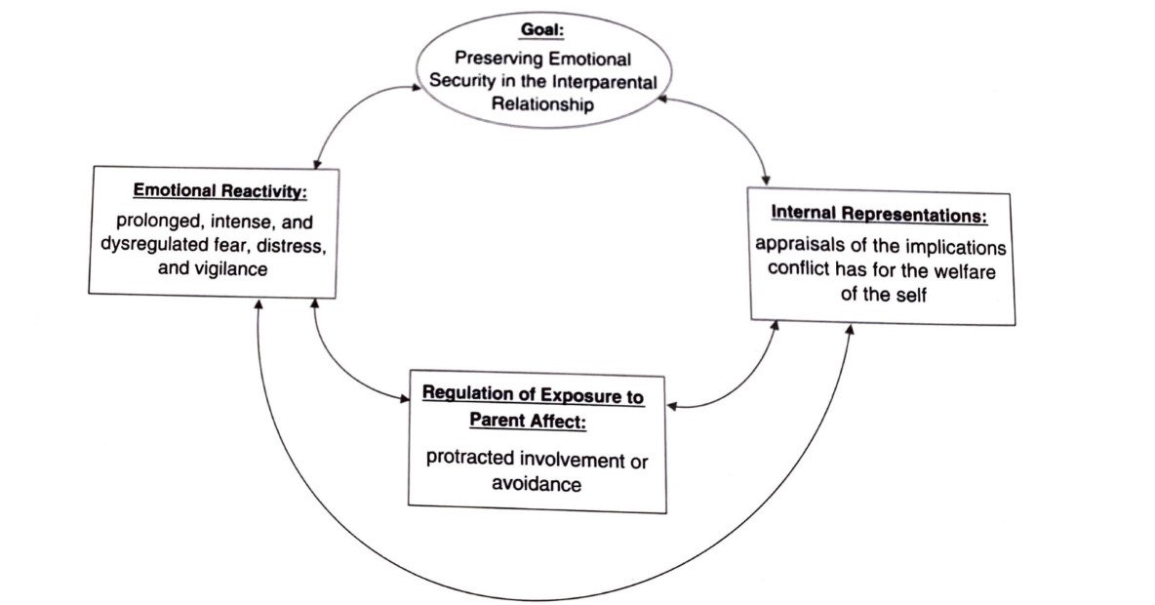

Emotional Reactivity
- Fearful, vigilant responses serve protective functions of priming the child to quickly identify and process potential threats, increasing accessibility to psychological resources to respond to stress, and facilitating acquisition and prompt recall of aversive interparental cues in scanning subsequent parent conflict.

Regulation of Parent affect
- Intervention and avoidance are served as direct protective functions to reduce the child’s exposure of interparental conflict

Internal Representations
- Prepare the child for potential danger by providing them with a template for scanning, understanding, and responding quickly to imminent interparental danger.

EST-R (revised)
- Children’s security is regulated by 2 models: social defense and attachment systems
- Both protect child from harm
- But distinct from each other in that they have (1) different goals, (2) unique conditions that increase their saliency as organizers of behavior, (3) action tendencies that regulate their external goals
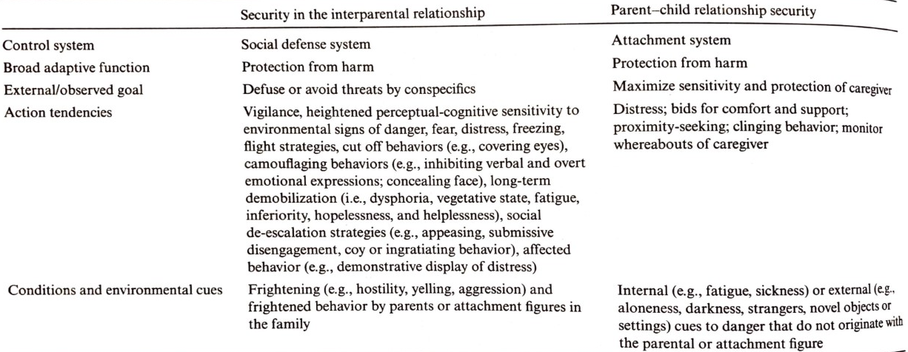
- Theory postulates that ES can be influences by the child’s temperament and personality
  - Research has found little association between the two and finds that temperament and personality are very distinct from security

DSM- Limitations
  - DSM does not have diagnoses related to relationships and family systems
    - Encourage using v-codes

Cognitive Risk factors

Models
- Transactional: variables can serve as an antecedent and an outcome and affect each other in a bidirectional manner
  - Negative environment onsets sadness, which then reinforces variables in negative environment
- Correlates: risk factors (cognitive deficits) are associated with psychopathology
- Causal: risk factors directly cause psychopathology
  - Not a lot of evidence, hard to manipulate in lab.

Processes
- Executive functioning (EF): processes that enable us to respond flexibly to the environment and regulate our thoughts and behaviors, allowing us to break out of habits, make decisions, and evaluate risks, plan, prioritize a sequence of actions, and cope with new situations.
    - Shifting: switching between tasks sets or response rules
    - Inhibition: resisting an automatic response to make a less-automatic, but task relevant response
    - Updating: monitoring and coding incoming information for task-relevance, and replacing no longer relevant information
    - Common EF: processes shared across all ED tasks- monitoring for and maintain goal and context information
  - Of disorders, schizophrenia appears to have greatest impact on EF
  - Somewhat present in mood disorders, but much smaller magnitude
  - OCD, some impairment in shifting and inhibition. Greater impairment in updating
  - PTSD and trauma-exposed struggle with shifting, and sometimes inhibition
  - Inconsistent findings for other anxiety disorders
  - EF deficits appear to be stable through development
- Working Memory (WM): actively maintaining or manipulating information across a short period of time.
  - Deficits found across disorders
    - Visuospatial WM deficits - schizophrenia large effect, BD & ADHD medium effect, OCD & MDD small effect
    - Verbal WM – schizophrenia large effect, BD & MDD & ADHD medium, PTSD and OCD small

Cognitive style
  - Negative inferential status: attribute negative events to internal, stable, and/or global causes. Also make stable and global inferences about the consequences of an event and believe neg events have neg implications for self (self is flawed b/c of event)
  - Dysfunctional attitudes: schemas (well organized cognitive representations of past experiences that represent knowledge of the world, relationships with others and the self. Depressive self-schemas represent a rigid core of beliefs related to performance, perfectionism, self-worth, and guide the selective processing of negative info in environment over positive.
    - Young’s early maladaptive schemas
      - Disconnection/rejection: believe others will not meet needs for security, acceptance, and respect.
      - Impaired autonomy: believe aspects of self and environment will interfere with their ability to function independently
      - Other directedness: extreme focus on the desires of others
      - Impaired limits: challenges exerting self-control
      - Over-vigilance/inhibition: negativity, pessimism, emotional inhibition, punitiveness
  - Hostile attribution bias: attribute hostile meaning of other behaviors/intentions in ambiguous situations
  - Looming Maladaptive Style: based in danger or threat schema. Biased expectations about the temporal and spatial progression of potential threats. Perceive potential threats as rapidly mounting, escalating, and approaching.
  - Repetitive negative thoughts: rumination
  - Emotion regulation strategies
    - Distraction
    - Cognitive reappraisal: ability to change how one thinks about the situation or one’s capacity to manage the situation

Summary of Cognitive Deficits by Disorder
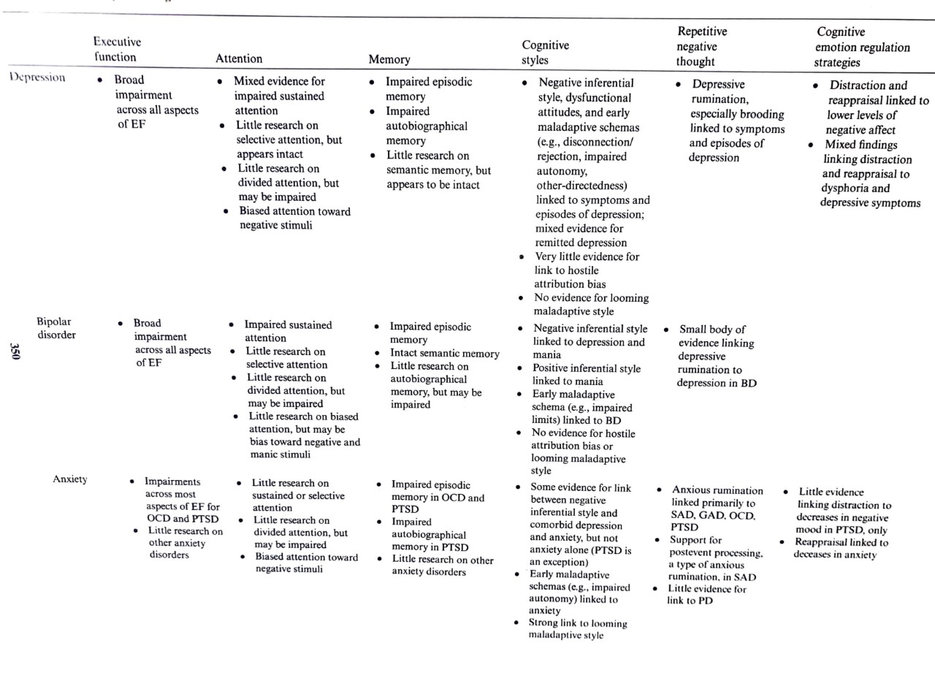
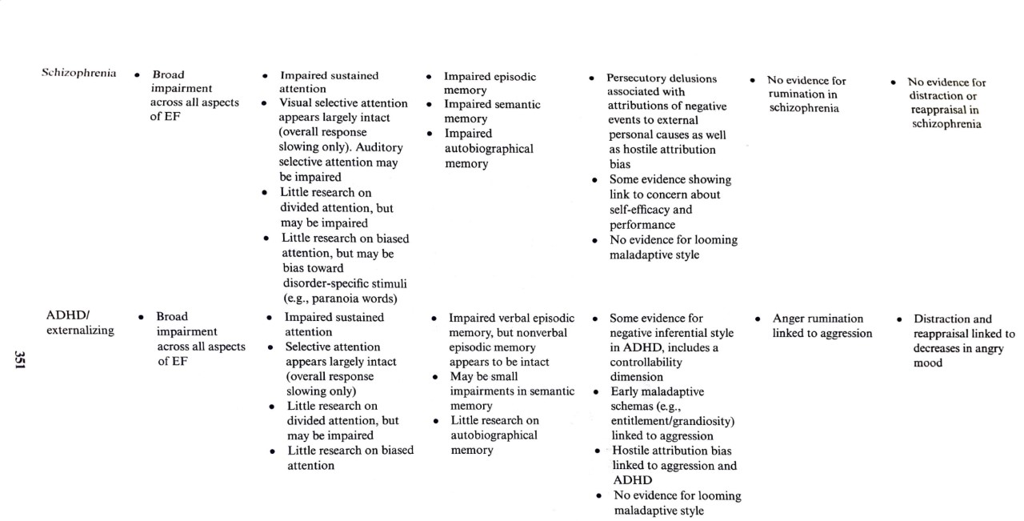

Child Maltreatment
- Challenges in clearly defining child abuse
  - Includes both acts of commission and omission

Spanking as a punishment
  - In last 30 years, researchers have found that spanking increases aggression and antisocial behavior in children
  - Teaches that physical force is an acceptable way to get a desired outcome
  - Doesn’t promote social skills or emotion regulation development
  - Cultural concerns: some communities (e.g. some Christians) believe in spanking
  - More acceptable among low-ses communities
- Many state-based differences in which allegations are investigates

Risk factors
- Child risk factors of maltreatment
  - Problems w/ drugs and alcohol, including infants born addicted.
  - Children w/ medical and mental health problems
  - Females
  - Children under 5 – least likely to resist, more likely to be hurt, and have more trouble communicating what happened
- Parental risk factors for child abuse
  - Lower level parent education
  - Low-ses
  - Immigrant status
  - Younger parents and single parents
  - Parents with psychopathology and/or substance problems
  - Housing insecure parents
- Family systems and environmental risk factors
  - Environments with high levels of conflict and violence, include parent (domestic), neighborhood, or community violence
  - Previous experiences of child abuse in family
  - Poor quality of relationship between parent and child

Risk of Psychopathology after Child Maltreatment
- Child abuse and psychopathology
  - PTSD one of most studied outcomes
  - Also, depression, substance use, anxiety, odd
    - Age of onset for alcohol use earlier
- Genetic risk factors
  - Having one or two copies of FK506 binding protein gene which is involved in regulating stress
  - Polymorphism of the corticotrophin-release hormone type 1 receptor (influences stress response) decreased likelihood of developing depression
- Cognitive risk factors after abuse
  - Low self-worth
  - Hopelessness
  - Challenges expressing emotions
  - Impulsive
  - More likely to be victimized again (as adolescent or adult)
- Controversy around complex PTSD or developmental PTSD

Protective factors
- High levels of MAOA (metabolizes neurotransmitters) decreased antisocial bhx in males who were abused
- High self esteem and perceived control
- Having at least one parent who was nurturing and warm
- Friend support or support from other family members

Divorce, Separation, and Loss
- Adjustment disorder often used when persistent issues arise in children
  - Some argue for a new disorder to better explain situation, such as persistent complex bereavement disorder

Risk Factors of Divorce
- Genetics
  - Twin studies have found that some adults are more likely to get divorced (twin studies found that a person is 250% more at risk to get divorce if their twin has)
  - Personality traits, genetic vulnerabilities
- Temperaments affects baby’s ability to adjust – thus some temperaments are harder to adjust after divorce
- Intelligence in child (SES?)
- Beliefs about divorce = variable reactions to it
- High conflict in home increases
- Adjustment of parents
- Negative parenting

Protective Factors of Divorce
- Positive parenting
- Income
- Pre-divorce adjustment functioning of child and family
- Positive parenting
- Effective discipline
Timing of divorce
- Some studies found that younger children have more trouble adjusting
  - Divorce may have effects on child’s developmental milestones or advanced at the time of divorce
  - Early divorce correlated to internal external problems, later divorce correlates to academic issues
Interventions after divorce
- Parent training
- Psychoed
- Coping skills

Death of a Parent
- Girls appear to develop more internalizing symptoms that are more persistent, whereas boys usually see a decline of milder symptoms after a few years
  - Cognitive vulnerability is higher in girls
Risk factors of trouble bereavement
- Low-SES
- Control beliefs
- Fear of abandonment
- Threat appraisal (misinterpretation of threats in new, difficult, or ambiguous situations)
- Caregiver mental health
- Earlier death has worse outcomes
  - Will re-experience grief over and over as they transition through developmental stages

  - 